BARANGAY MANAGEMENT INFORMATION SYSTEM

FOR THE MUNICIPALITY OF MAYANTOC

JOHN REY M. BOLOS

BRYAN C. MALLARI

JERENEL C. LACAULAN

JOHN CARLO F. ASUNCION

Republic of the Philippines

TARLAC AGRICULTURAL UNIVERSITY

Camiling, Tarlac

March 2023

# APPROVAL SHEET

# BIOGRAPHICAL SKETCH



On September 25, 2000, John Carlo Felizardo Asuncion was born at Barangay San Jose, Mayantoc, Tarlac. He is the oldest son among the three children of Juvy Siatrez Asuncion and Ofelia Agbayani Felizardo.

He spent his elementary education at San Jose Elementary School and finished on 2012. He continued his secondary education at the Mayantoc High School and finished at the year of 2017. But after spending his junior high school life at Mayantoc High School, he continued his senior high school at Glory Dei Montessori College and graduated on 2019. He took Bachelor of Science in Information and Technology for his dream to be an Information Technology Officer working under the office of Philippine National Police.

John Carlo F. Asuncion

**Researcher**

# BIOGRAPHICAL SKETCH

John Rey M. Bolos is currently a fourth year Information Technology (IT) student at the Tarlac Agricultural University. He was born in Santa Ignacia, Tarlac, on September 09, 2000.

He is the youngest among the siblings of Mr. Mateo C. Bolos and Mrs. Cely M. Bolos. In March 2006, he completed his kinder garden years at Población West Day Care Center at Santa Ignacia, Tarlac. Then he took his elementary years at Santa. Ignacia North Central Elementary School and finished in 2013. He pursued his high school years at Santa Ignacia Highschool in 2013 and ended with honor, and in year 2017, he took his senior high school years at the same school and finished with honor as well. He took Bachelor of Science in Information and Technology for his plan to work under government as an Information and Technology Professional.

Johnrey M. Bolos

**Researcher**

# BIOGRAPHICAL SKETCH

Jerenel C. Lacaulan is a fourth-year Information Technology (IT) student at the Tarlac Agricultural University. He was born in New Salem, Gerona, Tarlac, on December 14, 2000.

He is the youngest among the siblings of Mr. Jeremias N. Lacaulan and Mrs. Lorna C. Lacaulan. In March 2006, he completed his kinder garden years at Quezon Elementary School. Then he took his elementary years at Quezon Elementary School and finished in March 2013. He pursued his high school years at Quezon National High School and finished in the year 2017, and he took his senior high school years at the same school and ended with honors. He took Bachelor of Science in Information and Technology due to his intention to work for an IT related company.

Jerenel C. Lacaulan

**Researcher**

# BIOGRAPHICAL SKETCH

**POGI PO AKO!**

Bryan C. Mallari is a fourth-year Information Technology (IT) student at Tarlac Agricultural University. He was born in Calayaan Gerona, Tarlac on April 14, 2001.

He is the oldest among the siblings of Mr. Rudy T. Mallari and Mrs. Marissa C. Mallari. In March 2007, he completed his Day Care at Parsolingan Day Care Center. Then he took his grade 1 at Parsolingan Elementary School, continued the rest of his elementary years at Santa Ignacia South Central Elementary School, and graduated in 2013. He pursued his high school at Padapada National High School in 2013 and finished in 2017; he took his senior high school at the same school and completed it as a conduct awardee. He took Bachelor of Science in Information and Technology for his plan to be a Full Stack Web Developer.

Bryan C. Mallari

**Researcher**

# ACKNOWLEDGMENT

The researchers acknowledge and thank their adviser, Ms. Maria Regina M. Pablo. Thank their professor Dr. Sheila R. Lingaya and the panel members, Mr. Renel F. Dumlao, and Mr. Bryan Paul D. Danganan. Their guidance and advice carried the researchers through the hardship of writing their paper and developing their system. They also want to thank the other professors, who gave their comments and suggestions to improve the system and become more reliable.

They want also to give their special thanks to their parents, who watch, appreciate, and encourage them to pursue the achievements they are achieving right now. Their enthusiastic support and continuous prayer gave them the courage to finish their capstone project.

In addition, they want to thank the staff and residents of Barangay San Jose, Mayantoc, Tarlac for participating in the data gathering and evaluation. With all of you, we cannot finish this study. They would be also thanking their friends who tap their backs when they almost give up on finishing their capstone study.

Lastly, they would like to thank God for the continuous blessings that he gives us. He answered their prayers on completing this study. He supports and guides them in their difficulties and let’s pass through them. They will always trust you for their future.

# ABSTRACT

The study was to develop a web-based Management Information System for the Municipality of Mayantoc that serves as a helping tool to the barangay and offers a better service for residents to address their concerns immediately. The system is designed to generate accurate and reliable documents. In addition, the Barangay Management Information System helps the residents in requesting a barangay documents and reporting incidents.

The study hastens the requesting of records and reporting of incidents. The system's development process used the Water Fall Model phases, which include requirements, design, implementation, verification, and revision phases that enhance and build up the system. A total of 60 participants evaluated the system in terms of usability and functionality.

The Barangay Management Information System for the Municipality of Mayantoc has a substantial influence on future users, which is helpful to employees and citizens based on the system's accessibility and applicability to the barangay.

# TABLE OF CONTENTS

APPROVAL SHEET ii

BIOGRAPHICAL SKETCH iii

BIOGRAPHICAL SKETCH iv

BIOGRAPHICAL SKETCH v

BIOGRAPHICAL SKETCH vi

ACKNOWLEDGMENT vii

ABSTRACT viii

TABLE OF CONTENTS ix

LIST OF TABLES xii

LIST OF FIGURES xiii

INTRODUCTION 1

Background of the Study 1

Significance of the Study 2

Objectives of the Study 3

Scope and Delimitations 4

Definition of Terms 5

REVIEW OF RELATED LITERATURE AND STUDIES 6

Related Literature 6

Related Studies 8

METHODOLOGY 12

System Development Methodology 12

Data Gathering Procedures 14

System Design 15

Tools used in the Development 18

Evaluation 21

Respondents to the Evaluation. A number of fifteen (50) Residents of Mayantoc were randomly selected and (10) Barangay Staff. This sample size of the end-users was indicated by the committee of panel evaluators of this study. The residents were determined by random sampling: individuals with mobile, pc, and laptop devices who agreed to use or test the system application. 21

RESULTS AND DISCUSSION 22

Barangay Management Information System 22

User Requirements 23

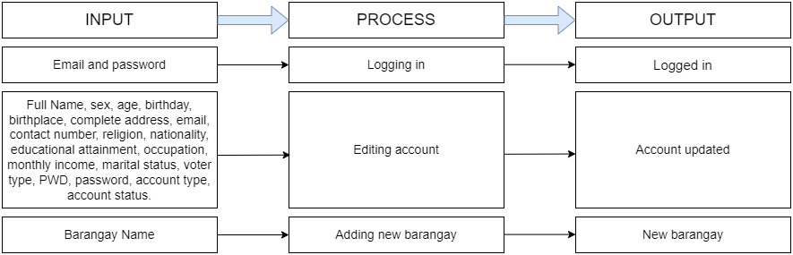 23

Hardware and Software Requirements 27

Evaluation of the System 28

SUMMARY, CONCLUSION AND RECOMMENDATION 37

Summary 37

Conclusion 37

Recommendation 38

REFERENCES 39

APPENDICES 42

LIST OF TABLES

Table 1. The scale used in the Analysis of the Result of Evaluation. 22

Table 2. Evaluation of Residents on Software Usability. 30

Table 3.Evaluation of Admin on Website Usability 31

Table 4. Evaluation of Residents on Website Functionality. 33

Table 5.Evaluation of Admin on Website Functionality. 36

LIST OF FIGURES

Figure 1. Development Paradigm of the Barangay Management Information System of the Municipality of Mayantoc. 13

Figure 2. Architectural Design of the Barangay Information System of the Municipality of Mayantoc 16

Figure 3. Entity Relationship Diagram of the Barangay Management Information System of the Municipality of Mayantoc 17

Figure 4. . Input-Process-Output of the Super Admin of the Barangay Information System of the Municipality of Mayantoc 24

Figure 5.Input-Process-Output of the Admin of the Barangay Information System of the Municipality of Mayantoc 25

Figure 6. Input-Process-Output of the Resident of the Barangay Information System of the Municipality of Mayantoc 26

Figure 7. Flow Chart Diagram Barangay Information System of the Municipality of Mayantoc 27

Figure 8.User Interface of the System for the Residents 31

Figure 9.User Interface of the System for the Admin 32

Figure 10.Registering Residents 34

Figure 11.Requesting of Document 34

Figure 12.Reporting of Incidents and Concerns. 35

Figure 13.Adding/Deleting/Updating Records and Searching Document/Files 36

Figure 14.Generating of Reports and Certifications 37

APPENDICES

Appendix A: User Interfaces

Appendix B: Questionnaire

Appendix C: End Users’ Evaluator Profile

Appendix D: Source Code

Appendix E: Grammarian Certificate

Appendix F: TAU-CET-QF-02 ADVISORY COMMITTEE

Appendix G: TAU-CET-QF-03 CAPSTONE TITLE APPROVAL

Appendix H: TAU-CET-QF-07 ORAL EXAMINATION

Appendix I: TAU-CET-QF-08 ORAL EXAMINATION

Appendix J: TAU-CET-QF-10 FINAL CIRCULATION

Appendix K: TAU-CET-QF-11 FINAL COPY OF MANUSCRIPT

# INTRODUCTION

## Background of the Study

Most barangays in the Philippines use computers for electronic tasks such as gathering residents' data, processing their files, documenting activities and crimes, presenting their achievements, and using spreadsheets for data recording. Using a system can increase productivity and provides better services to the barangay. The system helps the residents in efficiently addressing their issues. With the use of the system, they may have more time to discuss their concerns with the barangay officials online. The system can easily address request of documents and reports of incidents quickly.

The researchers developed a Management Information System which can assist the barangay authorities, particularly the secretary and chairman, to cope with their work efficiently. The system will provide a better method of data collection, more advanced data monitoring, well-secured data storage, and an easier way to gather the needed information. The system provides those workers an easy access to each resident’s information and give them the capability to create any required reports.

The Barangay Management Information System only allows authorized officials and residents with authority to access the barangay information and records services. The users can access it online using their preferred device with a pre-installed browser, such as cellphones, tablets, laptops, and personal computers. Residents may easily get documents and file reports through the systems at any time. The researchers' goal is to make the barangay's services more accessible to everyone. The system would act as a connection between residents and barangay services.

## Significance of the Study

The system is significant to the barangay personnel since it records the demographic profile of each residents and store it in more secured way.

It is helpful to each residents in terms of request for a certificates, permits, and clearances and to report anyone who violates the laws.

The system will benefit the country because it will enhance the gathering of citizens’ information to improve community services and quickly engage in programs offered by the government.

For the researchers, it would be used as a reference for future researchers who want to improve the management system of their barangays.

## Objectives of the Study

The main objective of the study was to develop a web-based Management Information System for the Municipality of Mayantoc:

Specifically, the study aims to achieve the following objectives:

1. to develop a Barangay Management Information System that consist of:

a.1 Registration module that will record the resident’s demographic profile.

a.2 Provide information about the barangay.

a.3 Module for residents’ request

a.4 Module for reporting unusual events that happened

1. to validate the proposed IT Solution through end user validation on:

b.1 Interface

b.2 Functionality

b.3 Usability

b.4 Security

Upon completion of the study, the Barangay authorities and residents will be able:

1. To utilize an effective and advanced information system.
2. To efficiently address barangay issues and concerns
3. To enhance the record system of the barangay.
4. To improve the quality of services for residents.

## Scope and Delimitations

Barangay Management Information System will serve as a helping tool to the authorities and staff of barangays in the Municipality of Mayantoc which offered a reliable storage of data of individuals in the barangay.

The system only permitted the administrator to change another user’s password if they were blocked due to erroneous password input. The system does allow users to view their demographic profiles. Only the administrator will be able to review and verify requests and reports of residents.

The suggested system focuses on existing system concerns such as Capacity, Backup, Monitoring, and Security to make system safer, robust, regularly backed up, and continually monitored to detect system flaws.

There are parameters that the researchers established in terms of time, population, size, and kind of assessment respondents or participants, among other things.

## Definition of Terms

**Accomplishment** The system successfully achieved the user's task in the system.

**Barangay** Is the Philippines’ lowest administrative division and a Filipino name for a village, district, or ward.

**Certificate** is a document that proves someone owns something.

**Clearance** is a document that grants someone the right to own something.

**Database** it is used to store or collect information.

**Demographic** it is the general characteristics of persons and populations, such as age, gender, and income. Are collected and analyzed.

**Flexibility** It shows how good the design of the system.

**Information** Data that has been sorted or categorized and has some relevant values to the recipient.

**Organization** It tells how well the arrangement of the data is in the system.

**Web-Based** can be access through pre-installed web browser.

# REVIEW OF RELATED LITERATURE AND STUDIES

## Related Literature

The Philippines is divided into local government units (LGUs) classed as provinces, cities, municipalities, and barangays, each with its own set of resources. Each staff uses a manual recording of each resident’s demographic profile. According to (Bondoc, 2019), in manual transactions, the quality of services declines as manual handling of transactions takes more time, is prone to human error, and is less secure in keeping records. On the other hand, designing and developing a barangay management system could help enhance the management of the different transactions. With the system, the generation of useful, up-to-date documents and reports and the ease of administration of varying barangay’s projects, programs, and activities will be possible (Bautista, 2015).

This barangay information management system will be possible with the help of the Database to store, retrieve, update, and delete data. According to (Susanto & Meiryani, 2019), the collection of the demographic profile of the residents is possible through the help of a Database Management System. Database Management System (database management system- DBMS) is software that makes it easy for organizations to centralize data, manage data efficiently, and provide access to application programs. DBMS acts as an interface between application programs and physical data files. When an application program calls a data file, such as gross salary, the DBMS searches this data in the Database and gives it to application program. DBMS relieves the task of the programmer or end-user to understand where and how the information is stored by separating logically and physically from the data. DBMS serves to reduce and eliminate data redundancy and maximize data consistency.

In the article (Saeed, 2017), the study is the solution to the problems stated to enhance the quality of service a barangay office offers to its clients. DBMS facilitates a better flow of information. Its application does the collection of data, processing of information, and controlling of information. It is needed for the function role, performance role, and support. The System ensures that the appropriate data is collected from various sources, processed, and sent to needy destinations.

The System is expected to fulfill the information needs of an individual/residents. The proposed study focuses on presenting possible solutions to the problems stated and enhancing the quality of service a barangay office offers to its clients or residents. Furthermore, the study serves as an awakening factor for all government offices, from highest to lowest levels, to align with the government’s view of globalization and competitiveness in today’s Information Age.

System quality is concerned with the System’s properties. Reliability, reaction, speed, system functioning, simplicity of use, and adaptability are characteristics. In contrast to system quality, information quality focuses on the AIS’s output properties. Some criteria associated with information are relevance, correctness, conciseness, completeness, usability, and timeliness (Nkanata, 2019). In the article of (Al-Okaily et al., 2020), as accounting information is the main output of AIS, it is easy to realize that these outputs should have prominent features of reliability, accuracy, and timeliness that influence performance.

A data description language processor (DDL processor) constructs the database, and a database manager distributes the database to users in all DBMSs. Data Manipulation and query languages are high-level software or software languages that resemble human language, allowing users to extract data and information from a database quickly. The database administrator, or DBA for short, is in charge of the Database and DBMS (Aken et al., 2017).

## Related Studies

The Philippines is divided into local government units (LGUs) classed as provinces, cities, municipalities, and barangays, each with its own set of resources. Each staff uses a manual recording of each resident’s demographic profile. According to (Bondoc, 2019), in manual transactions, the quality of services declines as manual handling of transactions takes more time, is prone to human error, and is less secure in keeping records. On the other hand, designing and developing a barangay management system could help enhance the management of the different transactions. With the system, the generation of useful, up-to-date documents and reports and the ease of administration of varying barangay’s projects, programs, and activities will be possible (Bautista, 2015).

This barangay information management system will be possible with the help of the Database to store, retrieve, update, and delete data. According to (Susanto & Meiryani, 2019), the collection of the demographic profile of the residents is possible through the help of a Database Management System. Database Management System (database management system- DBMS) is software that makes it easy for organizations to centralize data, manage data efficiently, and provide access to application programs. DBMS acts as an interface between application programs and physical data files. When an application program calls a data file, such as gross salary, the DBMS searches this data in the Database and gives it to application program. DBMS relieves the task of the programmer or end-user to understand where and how the information is stored by separating logically and physically from the data. DBMS serves to reduce and eliminate data redundancy and maximize data consistency.

In the article (Saeed, 2017), the study is the solution to the problems stated to enhance the quality of service a barangay office offers to its clients. DBMS facilitates a better flow of information. Its application does the collection of data, processing of information, and controlling of information. It is needed for the function role, performance role, and support. The System ensures that the appropriate data is collected from various sources, processed, and sent to needy destinations.

The System is expected to fulfill the information needs of an individual/resident. The proposed study focuses on presenting possible solutions to the problems stated and enhancing the quality of service a barangay office offers to its clients or residents. Furthermore, the study serves as an awakening factor for all government offices, from highest to lowest levels, to align with the government’s view of globalization and competitiveness in today’s Information Age.

System quality is concerned with the System’s properties. Reliability, reaction, speed, system functioning, simplicity of use, and adaptability are characteristics. In contrast to system quality, information quality focuses on the AIS’s output properties. Some criteria associated with information are relevance, correctness, conciseness, completeness, usability, and timeliness (Nkanata, 2019). In the article of (Al-Okaily et al., 2020), as accounting information is the main output of AIS, it is easy to realize that these outputs should have prominent features of reliability, accuracy, and timeliness that influence performance.

A data description language processor (DDL processor) constructs the database, and a database manager distributes the database to users in all DBMSs. Data Manipulation and query languages are high-level software or software languages that resemble human language, allowing users to extract data and information from a database quickly. The database administrator, or DBA for short, is in charge of the Database and DBMS (Aken et al., 2017).

# METHODOLOGY

## System Development Methodology

The researchers used the implemented the Water Fall Model. This includes requirements, design, implementation, verification, maintenance, and revision phases.

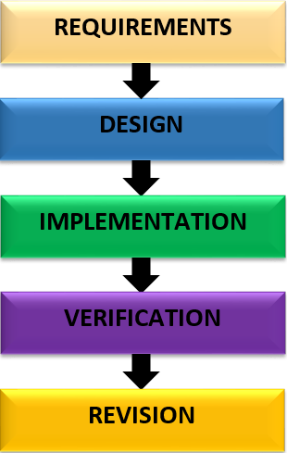

Figure 1. Development Paradigm of the Barangay Management Information System of the Municipality of Mayantoc.

**Requirements Phase**. In this phase, the researchers study how the barangay staff properly and carefully gather information of each residents, how to record each data and how to safely store it, how the resident request is being process, how to issue the request, and the researchers gather all the possible documents that the barangay offered.

**Designing Phase**. During this phase, the data gathered will be designed, including the Entity Relationship Diagram, Flowchart Diagram, and specially the interface of super admin, admin and the resident.

**Implementation Phase**. In this phase, the researchers will begin the development of the information system. The researchers will implement the design done during the designing phase. In creating the interface the researcher used HTML, CSS, and JavaScript and to make the system’s function they used PHP. While the database used to store all data is MySQL.

**Verification Phase**. In this phase, the system will be evaluated by both resident and barangay secretary from the barangay, to test the functionality, interface, usability, and security of the system, to also check and look for bugs and errors that need to be fixed.

**Revision Phase**. In this phase, the researchers will revise all errors and fix all the bugs in the system, consider the comments and suggestion of the users, and make the improvement needed under the verification phase.

## Data Gathering Procedures

The researchers conducted an interview to gather all necessary data that will serves as guide in developing the System. The researchers prepared a questionnaire checklist for the respondents which is validated by the capstone adviser and distributed on selected residents and barangay personnel who participated the survey. The researchers explained to the respondents about the significance of their responses to the study. The researchers requested to the respondents to answer the questionnaire sincerely. The researchers simplifies some terms to the respondents in the survey questionnaire in order to answer freely with complete knowledge of their obligations as the respondents of the study. The researchers used a mobile device and laptop to test the system. The researchers demonstrate the features of the system usability and functionality, thorough residents have knowledge on how the system works.

## System Design

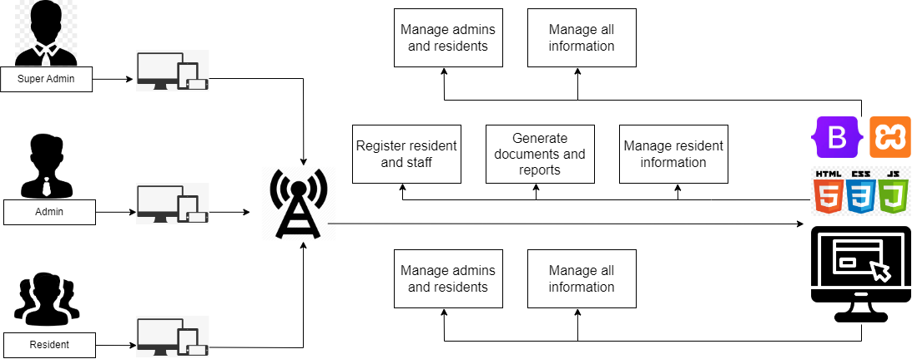

Figure 2. Architectural Design of the Barangay Information System of the Municipality of Mayantoc

The Barangay Management System has only three types of users, the administrator for the super admin which covered all the barangays, the administrator for the barangay admin and the resident which is verify as the clients. As seen in Figure 2, the system was developed using HTML, CSS, PHP, and JavaScript. The database of the system was designed using MySQL. This was used to store all the information in the system.

The super admin verifies and manages all information of both residents and admins, while the admin registers the residents and store staff information, and manages the information added in the system. The admin can also generate the requested documents and verify incident report of each resident. Then each resident can request any documents related to barangay services and able to report incident like blotters.

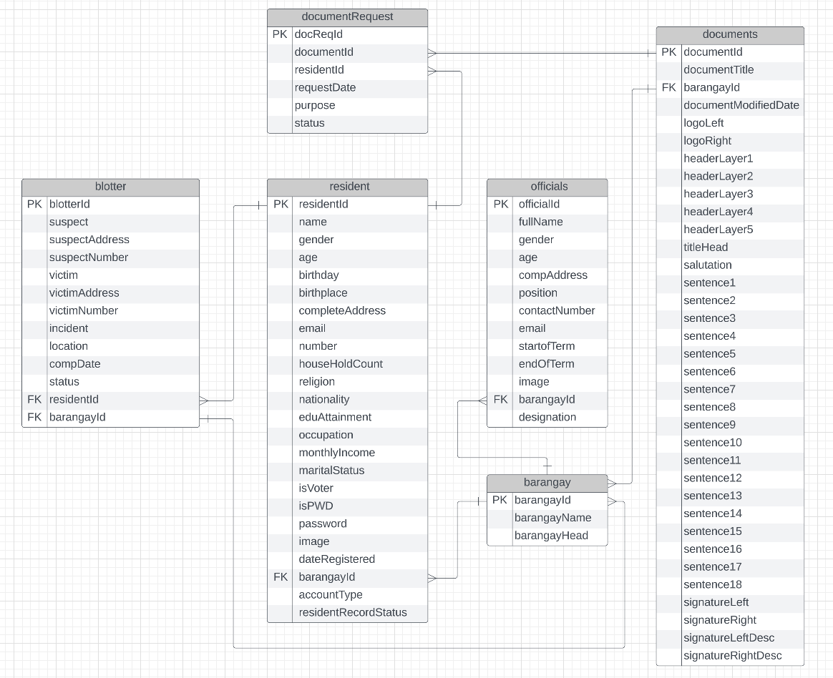

Figure 3. Entity Relationship Diagram of the Barangay Management Information System of the Municipality of Mayantoc

As seen in Figure 3, the Barangay Management Information System consist of six (6) tables, each table has a primary key and foreign key which is connected in every table.

The blotter and resident table are linked by the key column residentId. It is a foreign key in the blotter table linking to the primary key residentId in the resident table. Therefore, only one record of the resident table can point to multiple records in the blotter table, because residents can perform reports of blotter several times which is a one-to-many relationship. The blotter table and barangay table are linked by the key column barangayId, which is a foreign key in the blotter table and a primary key in the barangay table. Since, residents can file blotters in other barangay which correspond to the location of the suspect. That means it is a one-to-many relationship.

Resident table and Document Requests are linked together by the key column residentId which is a primary key in both tables. Hence, residents can request different documents using the system. This makes a one-to-many relationship. At the same time, the table DocumentRequests is linked by the key column DocumentId which is a primary key to the DocumentRequest table and also a primary key to the documentId in Documents table. Thus, upon acquiring documents, residents must send a request to the admin which includes their personal information and purpose, that may serve as a validation on generating documents. So, this makes a one-to-many relationship. Similarly, the documents table and barangay table are linked via a one-to-many relationship. Since each barangay can request different documents, the admin can add a new document form, which is formatted according to the composition of each barangay document. As well as the barangay and residents table are connected via one-to-many relationship, and linked by the key column barangayId which is a primary key in the barangay table and a foreign key in the resident table. Thus, the barangay holds the resident's information and residents are covered by the barangay. While officials’ tables are connected to the barangay table via one-to-many relationship, since each barangay has its own list of their barangay officials to the system.

### Tools used in the Development

The following hardware and software were used to develop the Barangay Information Management System of the Municipality of Mayantoc.

**Hardware.** The researchers’ used a laptop that served as a tool for coding the System.

The hardware specifications are indicated below:

Server Side:

**Processor**: Intel Core i3 or higher

**RAM**: 4 GB or higher

**Hard Disk Drive:** 500 GB or greater

Client Side:

Smartphones

Laptop

Personal Computer

Tablet

**Software.** The software used by the researchers in developing the project.

Programming Languages used:

Operating System (Window 8 or 10)

PHP, XAMPP, MySQL

HTML, CSS, Bootstrap

* **Programming/Scripting Language.**

The researchers used HypetextMarkup Language or HTML for the structure of each web page. Cascading Style Sheet or CSS is used to design the HTML, and with the help of Bootstrap, it becomes more responsive. On the other end of the System, the researchers used PHP for the functions and MySQL to store the data, then XAMPP was used as a temporary server.

* **DBMS**. The gathered data will automatically store in the Database and can retrieve, edited, and deleted by just the admin. Moreover, no residents can do so to avoid human error, and no outsiders can use the System.

## Evaluation

**Scale used in the Evaluation.** The barangay management information system was evaluated using the scale indicated in Table 2. The users also used a scale to determine the System's usability and functionality, where each parameter was detailed more specifically in the questionnaire to understand the evaluators better.

Table 1. The scale used in the Analysis of the Result of Evaluation.

|  |  |
| --- | --- |
| **first** | **level heading** |
| 4.50 – 5.00 | Excellent |
| 3.50 – 4.49 | Good |
| 2.50 – 3.49 | Average |
| 1.50 – 2.49 | Poor |
| 0.00 – 1.49 | Fair |

Respondents to the Evaluation. A number of fifteen (50) Residents of Mayantoc were randomly selected and (10) Barangay Staff. This sample size of the end-users was indicated by the committee of panel evaluators of this study. The residents were determined by random sampling: individuals with mobile, pc, and laptop devices who agreed to use or test the system application.

# RESULTS AND DISCUSSION

## Barangay Management Information System

The Barangay Management Information System was developed with an intent to help each barangays secretary and residents in terms of requesting and issuing barangay certificates, certificate of indigency, business permits and any other documents offered by the barangay. This is to reduce the efforts of each resident to request the documents that they need in the barangay hall. The system has three users: super admin, admin, and resident. The super admin is the one who has the authority over the resident to admin. The super admin can activate and block resident. The super admin is the one who manage all the data from each barangay. The admin is the one who process each documents requested, they have the authority to add edit and delete residents, and they also add each barangay officials to the system. The resident can only request documents offered by the barangay and report blotters.

### User Requirements

### Figure 4. Input-Process-Output of the Super Admin of the Barangay Information System of the Municipality of Mayantoc

The super admin is the one who has the authority to promote the resident to admin and demote it as a normal resident. The super admin also has the authority to activate and block each resident. The super admin is the one who manage both residents and admins.

To access the Super Admin the system will asks the user to log in by entering the email and password and then they will be directed to dashboard if they input valid information. The super admin dashboard has a total number of residents who requested documents which are sorted by age, it also separately shows the number of PWD and senior citizens from the dashboard.

The super admin also has an access to admin and resident. It can also edit and update the user’s account. Only the Super admin can change the admin of each barangay. The super admin also has the authority to manage admin and resident information.

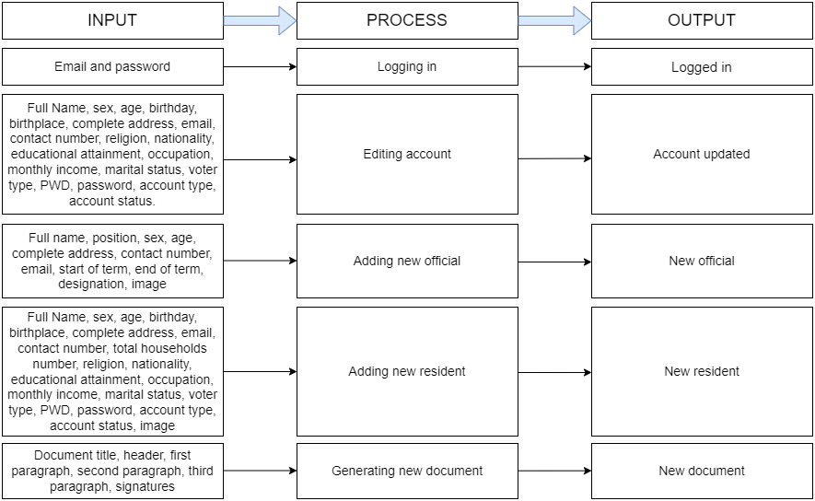

Figure 5. Input-Process-Output of the Admin of the Barangay Information System of the Municipality of Mayantoc

To enter the admin dashboard, the valid admin (usually staff) need to log in by entering the admin valid account which is verified by the Super Admin. The Admin can also update each resident account by their editing their personal information. In addition, Admin has a function to add new officials and edit their information. Besides, Admin is capable of adding new residents by filling up the provided form which contains resident’s information. Moreover, in generating a document the admin can able to create new document forms and edit it in case of new document formats requested.

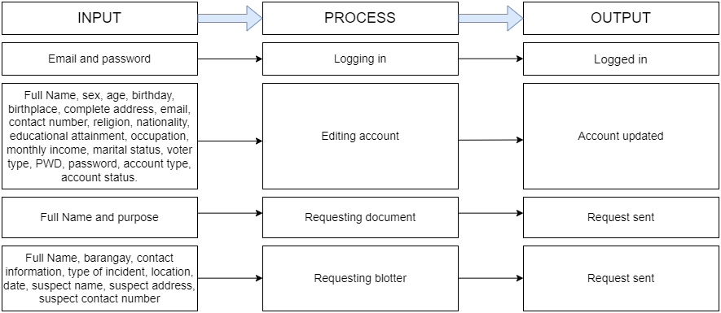The super admin also has an access to admin and resident. It can also edit and update the user’s account. Only the Super admin can change admin’s. The super admin also has the authority to manage admin and resident interface.

Figure 6. Input-Process-Output of the Resident of the Barangay Information System of the Municipality of Mayantoc

More likely to the admin function, The Resident also required to log in by entering a registered account given by the Admin. The Resident side is able to update user’s information which will be assisted by the admin. Furthermore, residents are capable of requesting documents like certificates, permits, clearances and other documents offered by the barangay by sending their full name including the purpose. The resident can also request blotters by sending dominant information. Hence, each request will be authenticated where can be approved or disapproved by the admin.

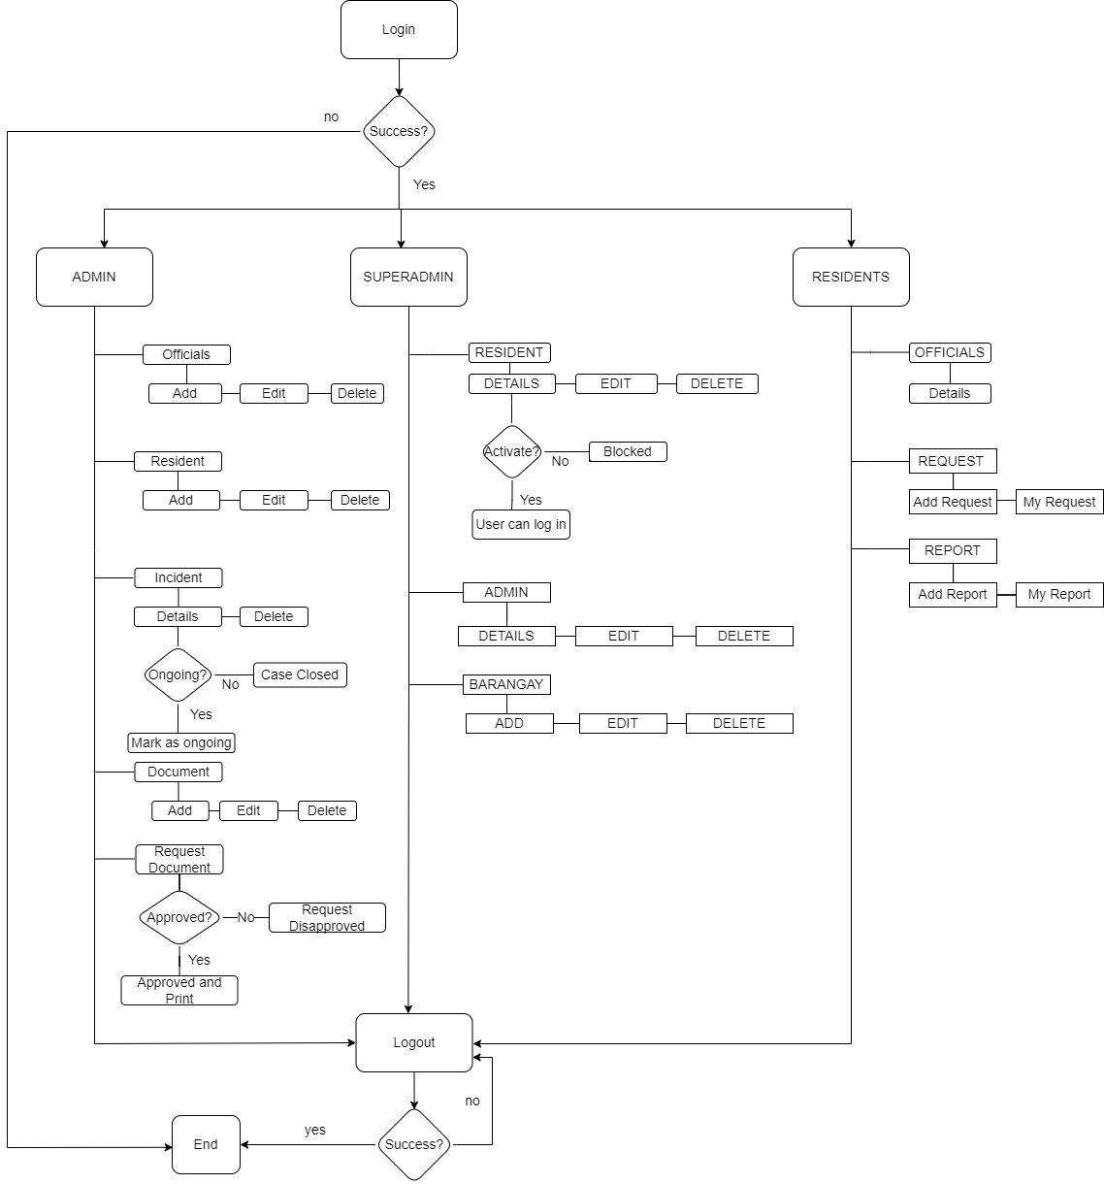

Figure 7. Flow Chart Diagram Barangay Information System of the Municipality of Mayantoc

The flow chart diagram in Figure 7, describes the function of the Barangay Information System. The user needs to login in the system. If the system recognizes the entered username and password the process will continue, if not the flow will end. The system has three section of users the super admin, admin, and resident interface. The super admin activates the users of the system, and it has the ability to block each user. If the users are activated, the super admin can assign each resident as an admin and resident. Each user will be given username and password that they can used to enter the system. In the admin interface, it has a function that can add, edit, and delete official’s demographic profile. The admin can also create document and let the resident request those documents, and it has the ability to approve and disapprove those pending request. Furthermore, in the admin interface it can review those resident’s report and mark it as “ongoing” and “case close”.

### Hardware and Software Requirements

The barangay management information system for the municipality of mayantoc can run with the minimum hardware and software requirements listed below.

Hardware:

**Admin side:**

Processor: Intel Core i3 or higher

RAM: 4GB

HDD: 500 GB or greater

Connectivity: 4G

**Resident Side:**

RAM: 2GB

Connectivity: 4G

Software:

**Admin Side:**

Windows 7 or higher

Web Browser

**Resident Side:**

Android/IOS

Web Browser

## Evaluation Results

The users evaluated the system based on the criteria of the specific objectives. These criteria were simplified for the users to understand what to evaluate in the system. The user is composed of random residents on each purok in Barangay San Jose Mayantoc, Tarlac, and chosen staff to evaluate the admin interface of the system.

A total of 50 residents and 10 barangay staff such as the Chairman, Secretary, and Treasurer, including 5 Kagawads and SK Chairman were evaluated the system in terms of usability and functionality.

Table 2. Evaluation of Residents on Software Usability.

|  |  |  |
| --- | --- | --- |
| **1. USABILITY** | **AVERAGE** | **DESCRIPTIVE RATING** |
| 1.1 Organization of data. | 4.50 | Excellent |
| 1.2 Accomplishment of tasks. | 4.50 | Excellent |
| 1.3 Flexibility of interface design. | 4.56 | Excellent |
| 1.4 The system is easy to learn. | 4.82 | Excellent |
| **Section Mean** | **4.60** | **Excellent** |

Table 2 shows the Evaluation of residents on Software Usability, which consists of four questions. The question 1.1, Organization of data has evaluated by residents with a 4.50 mean average which has a descriptive rating as Excellent. As well as the question 1.2, Accomplishment of tasks has evaluated with a 4.50 mean average which is also described as excellent. Furthermore, the flexibility of interface design in question 1.3 has evaluated with a mean average of 4.56 and has a descriptive as Excellent. Including question 1.4 The system is easy to learn has evaluated with an average mean of 4.82, which is excellent). In conclusion, the residents evaluated the system’s software usability as excellent with a section mean average of 4.63.

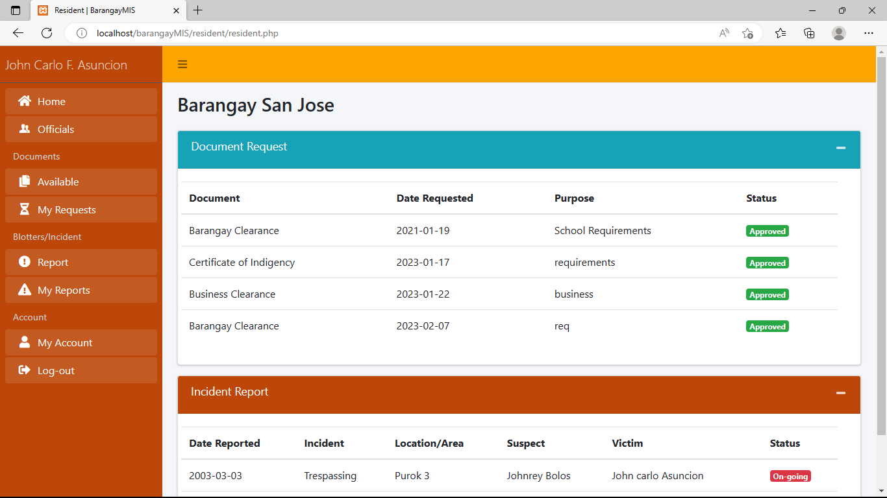

Figure 8.User Interface of the System for the Residents

Figure 8 shows the Barangay Management Information System user interface for the resident's dashboard. According to the residents, the system interface was good and flexible. In requesting a document, residents was easily send their request using the system. In addition, reporting of incident like blotter was immediately mailed. Hence, the Barangay Management Information system has provided a quality service on residents and barangay personnel which addressed in the evaluation.

Table 3.Evaluation of Admin on Website Usability

|  |  |  |
| --- | --- | --- |
| **1. USABILITY** | **AVERAGE** | **DESCRIPTIVE RATING** |
| 1.1 Organization of data. | 4.60 | Excellent |
| 1.2 Accomplishment of tasks. | 4.50 | Excellent |
| 1.3 Flexibility of interface design. | 4.30 | Good |
| 1.4 The system is easy to learn. | 4.90 | Excellent |
| **Section Mean** | **4.58** | **Excellent** |

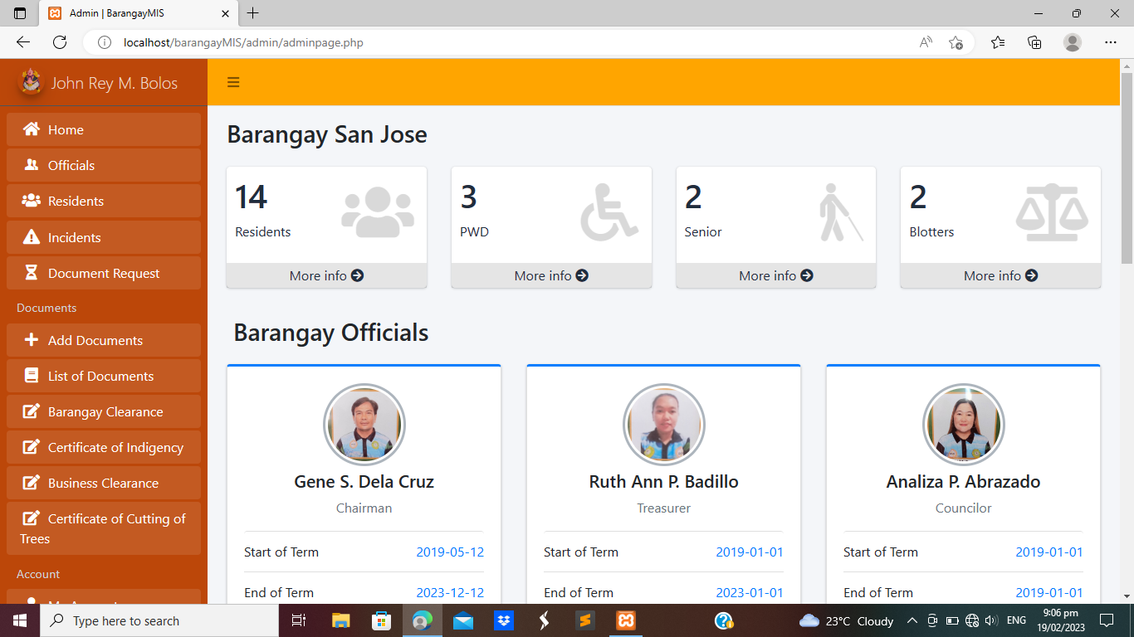Table 3 signifies that the Organization of data (mean = 4.50, Excellent), Accomplishment of task (mean = 4.50, Excellent), Flexibility of interface design (mean = 4.82, Excellent), the residents evaluated the system’s software usability as excellent with a section mean of 4.63.

Figure 9. User Interface of the System for the Admin

Figure 9 indicates the system interface for the admin dashboard, where barangay officials are displayed, total population of the barangay, and numbers of person with disability, numbers of senior citizens, and numbers of blotters. Side bar navigation is also displayed on the admin dashboard to navigate on through different pages of the system.

Table 4. Evaluation of Residents on Website Functionality.

|  |  |  |
| --- | --- | --- |
| **2.FUNCTIONALITY** | **AVERAGE** | **DESCRIPTIVE RATING** |
| 2.1 Submitting files and document. | 4.56 | Excellent |
| 2.2 Generating of certifications, records, and other documents. | 4.66 | Excellent |
| 2.3 Requesting of Documents | 4.66 | Excellent |
| 2.4 Reporting of Incidents and Concerns. | 4.72 | Excellent |
| **Section Mean** | **4.65** | **Excellent** |

Table 4 indicates that submitting of files and documents (mean = 4.56, Excellent), Generating of certifications, records, and other documents (mean = 4.66, Excellent), Requesting of documents (mean = 4.66, Excellent), Reporting of incidents and concerns (mean = 4.72, Excellent). The system’s website functionality was rated excellent by the residents with the section mean of 4.65.

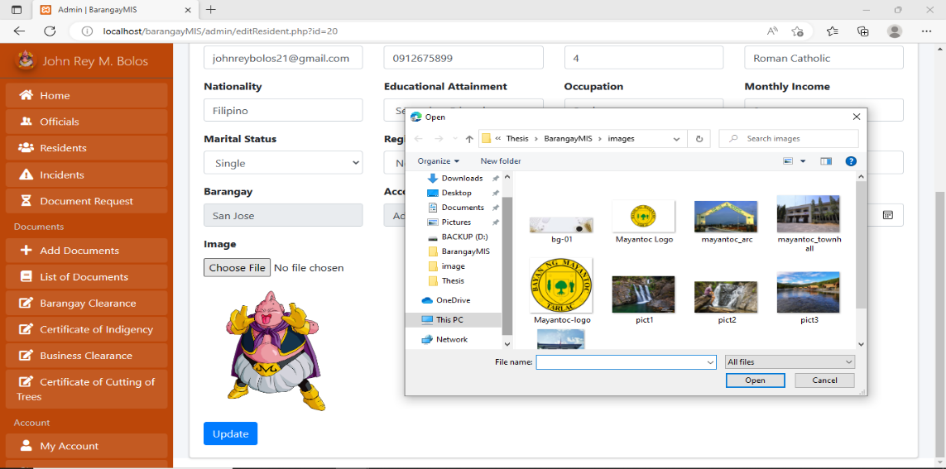

Figure 10. Registering Residents

In Figure 10 shows the interface when admin register a resident, all the input fields are required to be filled out including the image of the resident.

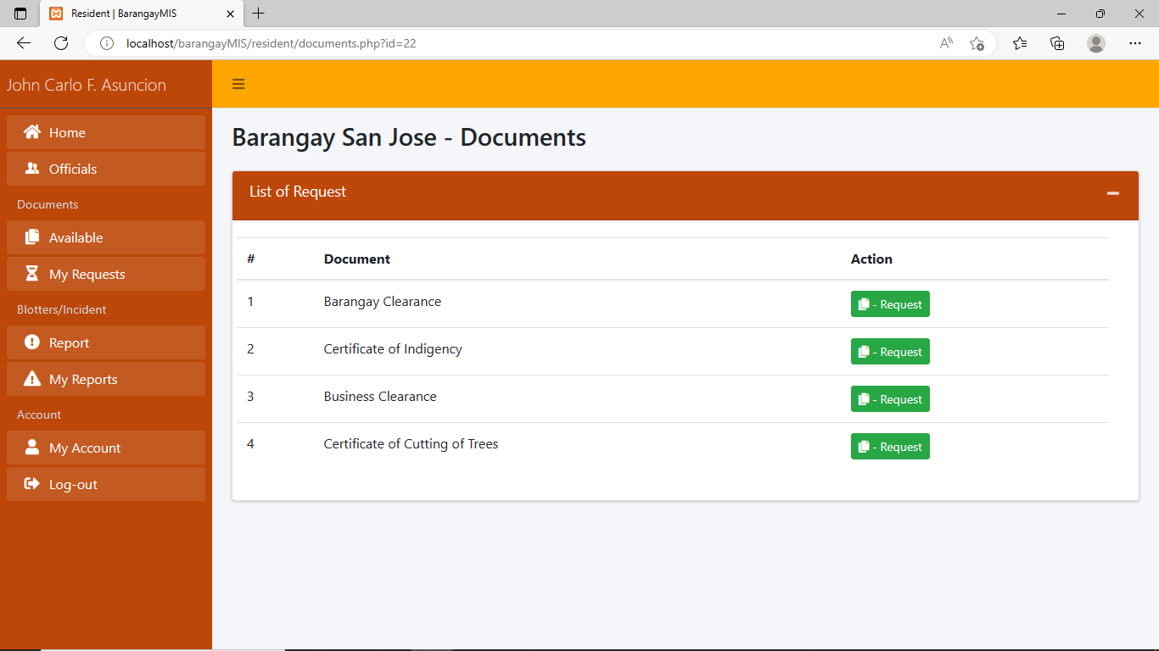

‘

Figure 11.Requesting of Document

Moreover, requesting documents such as a certificate of indigency, barangay clearance, and business permits can be done by clicking request button as shown in Figure 11.

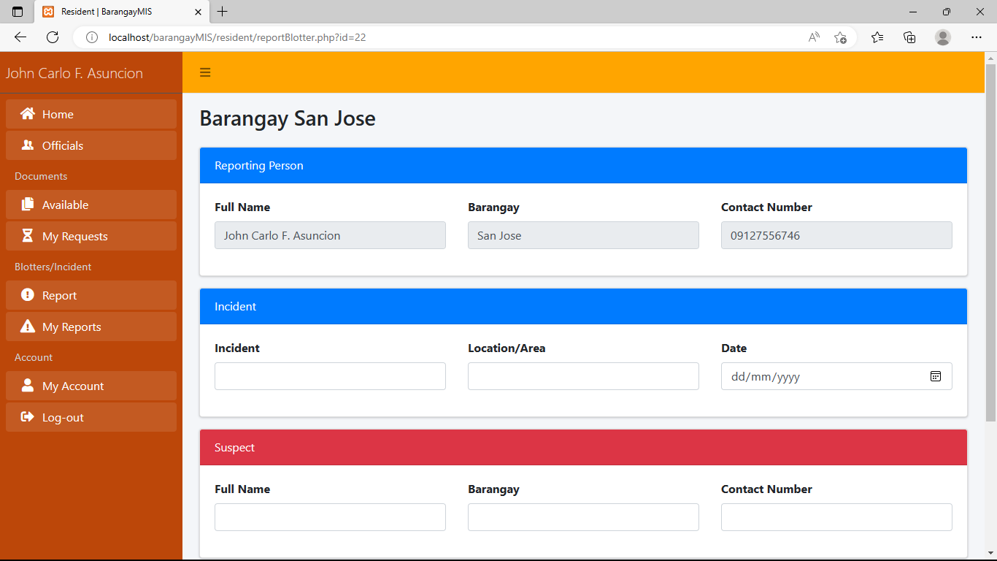

Figure 12.Reporting of Incidents and Concerns.

Figure 12 shows the reporting of incidents and concerns. In reporting of incidents and concerns complainant must fill up a form first and submit it or click send request, then admin will examine the report, then decides if the request is approved or not.

Table 5.Evaluation of Admin on Website Functionality.

|  |  |  |
| --- | --- | --- |
| **2. FUNCTIONALITY** | **AVERAGE** | **DESCRIPTIVE RATING** |
| 2.1 Adding, Deleting, and Updating Records. | 4.50 | Excellent |
| 2.2 Generating of reports and certification. | 4.70 | Excellent |
| 2.3 Searching of documents/files. | 4.30 | Excellent |
| 2.4 Uploading of documents/files. | 4.90 | Excellent |
| **Section Mean** | **4.60** | **Excellent** |

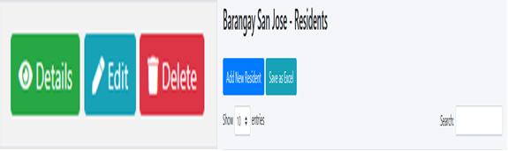Table 5, indicates that adding, updating, and deleting records (mean = 5.0, Excellent). Generating of reports and certification (mean = 5.0 Excellent), Searching of documents/files (mean= 5.0, Excellent), and uploading of documents/files (mean =5.0, Excellent). The system’s website functionality was rated Excellent by the administrators with a section mean of 5.00.

Figure 13.Adding/Deleting/Updating Records and Searching Document/Files

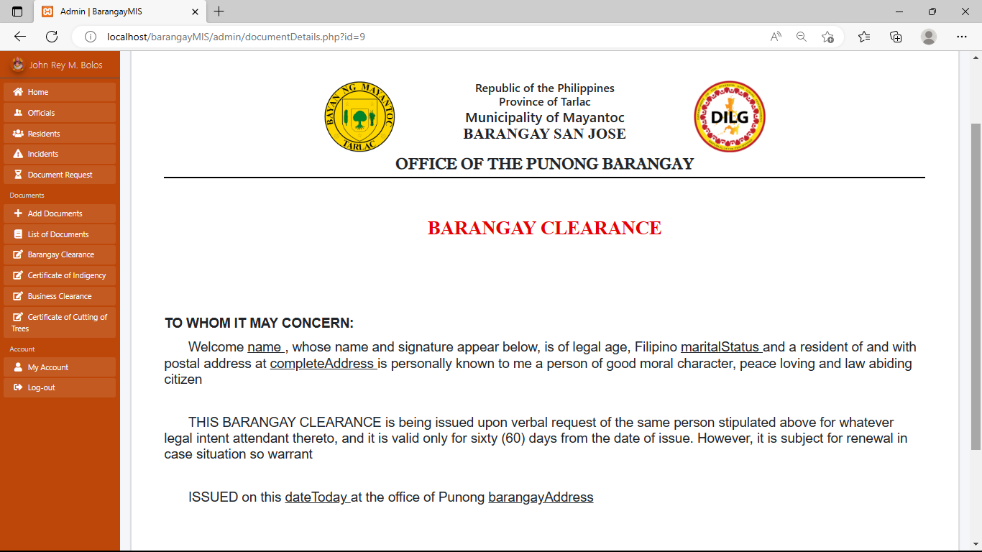Figure 13 shows that only the admin can add, update, and delete residents' records for this figure. In searching documents or files, the admin may also use gender, age, birthday, and resident’s id on the search bar.

Figure 14.Generating of Reports and Certifications

Figure 14, Shows an example of generated reports and certifications. In this feature, documents or files such as barangay certifications, permits, and reports are auto generated. The admin can also view and print it directly.

# SUMMARY, CONCLUSION AND RECOMMENDATION

## Summary

This study was proposed to build a more reliable and efficient Barangay Management Information System for the Municipality of Mayantoc, which can help residents on requesting documents like Certificate of indigency, Barangay Clearance, Business Permit, and blotter form. Barangay personel, especially the secretary, can easily generate records of residents' information and helps them issue important documents of the barangay, such as certificate of indigency, Barangay Clearance, blotter forms, and business permits through the use of the system. The suitability of the system was evaluated by future users. Feedback was given along with rating on the system’s usability and functionality, which resulted as Excellent.

## Conclusion

Based on the findings of the study, the following conclusions were derived

1. The Barangay Management Information System for the Municipality of Mayantoc improves the quality of barangay services which offers an efficient web-based application system for requesting documents and reporting incidents by the resident.
2. The findings revealed that Barangay Management Information System for the Municipality of Mayantoc provides more reliable service for the barangay and to all residents of Mayantoc.
3. The results of evaluation on this study proved that Barangay Management Information System has a big impact on the residents of Mayantoc, for being accessible barangay services.

## Recommendation

The researchers can exhaust all means and may recommend the following:

1. Future researchers can include signature generator which are not included in the system.
2. SMS and Email API’s for the status and updates of the request is also a better addition to the system services
3. In the future, researchers can add a heatmapping tools for better profiling to see which barangay has a lot of reports and requests.

# REFERENCES

Aken, Dana Van, Andrew Pavlo, Geoffrey J. Gordon, and Bohan Zhang. 2017. “Automatic Database Management System Tuning through Large-Scale Machine Learning.” *Proceedings of the ACM SIGMOD International Conference on Management of Data* Part F127746: 1009–24. https://doi.org/10.1145/3035918.3064029.

Al-Okaily, Aws, Manaf Al-Okaily, Fadi Shiyyab, and Walid Masadah. 2020. “Accounting Information System Effectiveness from an Organizational Perspective.” *Management Science Letters* 10 (16): 3991–4000. https://doi.org/10.5267/j.msl.2020.7.010.

Bautista, Rosemarie M. 2015. “Promoting Digital Empowerment through Implementation of Barangay Management System.” *International Journal of Engineering Research and General Science* 3 (2): 563–69. www.ijergs.org.

Beigzadeh, Shima, Mazdak Zamani, and Suhaimi Ibrahim. 2011. “Development of a Web-Based Community Management Information System.” *Proceedings - 4th International Conference on Information and Computing, ICIC 2011*, 3–6. https://doi.org/10.1109/ICIC.2011.52.

Bondoc, Bren Castro. 2019. “Towards Digitization through E-Barangay ‘A Web-Based Barangay Information System.’” *Journal of Humanities and Education Development* 1 (2): 88–91. https://doi.org/10.22161/jhed.1.2.5.

Fakhimuddin, Muhammad, Uswatun Khasanah, and Rini Trimiyati. 2021. “Database Management System in Accounting: Assessing the Role of Internet Service Communication of Accounting System Information.” *Research Horizon* 1 (3): 100–105. https://doi.org/10.54518/rh.1.3.2021.100-105.

Nkanata, Mercy G. 2019. “Applying DeLone and McLean Information Systems Success Model in Evaluation of E-Government Initiatives : A Literature Review.” *In Proceedings of 20th Annual IS Conference*, no. Volume 18: 287.

Saeed, Adham Mohsin. 2017. “Role of Database Management Systems (DBMS) in Supporting Information Technology in Sector of Education.” *International Journal of Science and Research (IJSR)* 6 (5): 1462–66. https://doi.org/10.21275/ART20173499.

Susanto, Azhar, and Meiryani. 2019. “Database Management System.” *International Journal of Scientific and Technology Research* 8 (6): 309–12. https://doi.org/10.5120/179-310.

Wang, Shu, Tianrui Li, Chuan Luo, Hongmei Chen, and Hamido Fujita. 2019. “Domain-Wise Approaches for Updating Approximations with Multi-Dimensional Variation of Ordered Information Systems.” *Information Sciences* 478: 100–124. https://doi.org/10.1016/j.ins.2018.11.014.

Wibowo Yunanto, P, D Nurhidayat, and R Wicaksono. 2019. “Development of Web-Based Information System for Universitas Negeri Jakarta.” *KnE Social Sciences* 3 (12): 453. https://doi.org/10.18502/kss.v3i12.4113.

Yang, Dawei, Daojiang Wang, Dongming Yang, Qiwen Dong, Ye Wang, Huan Zhou, and Hong Daocheng. 2020. “DevOps in Practice for Education Management Information System at ECNU.” *Procedia Computer Science* 176: 1382–91. https://doi.org/10.1016/j.procs.2020.09.148.

APPENDICES

##### Appendix A: User Interfaces

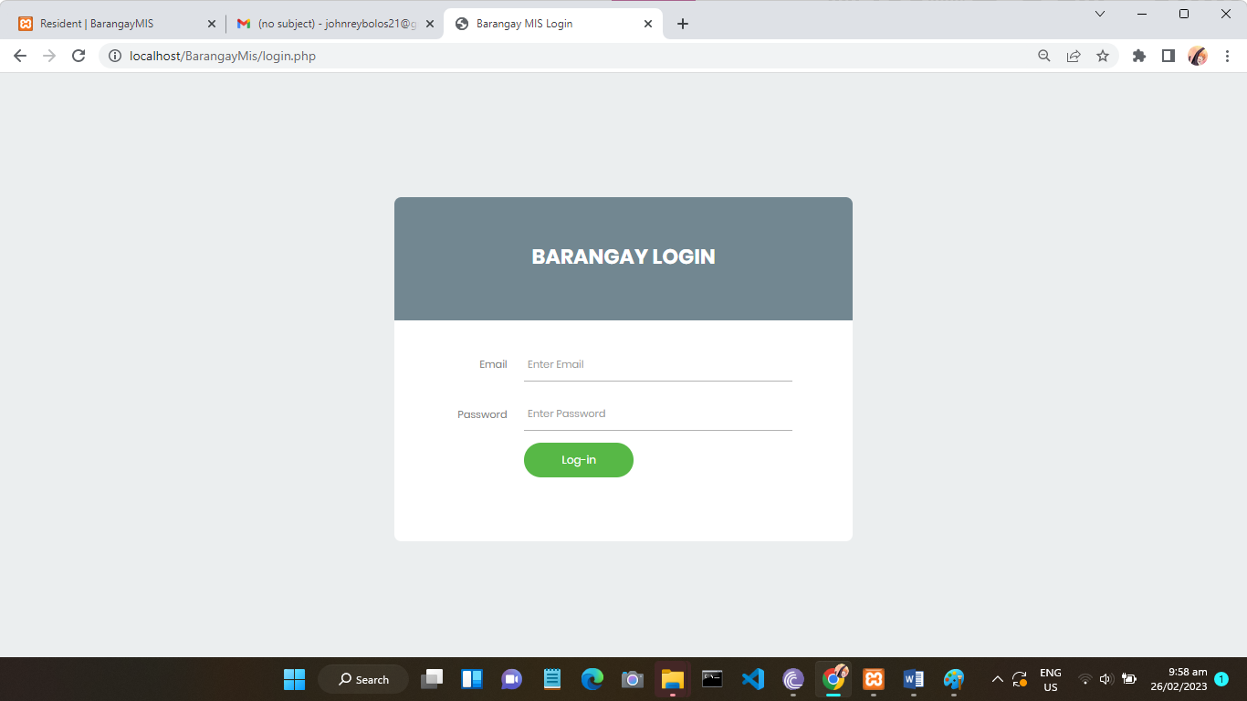**LOGIN PAGE**

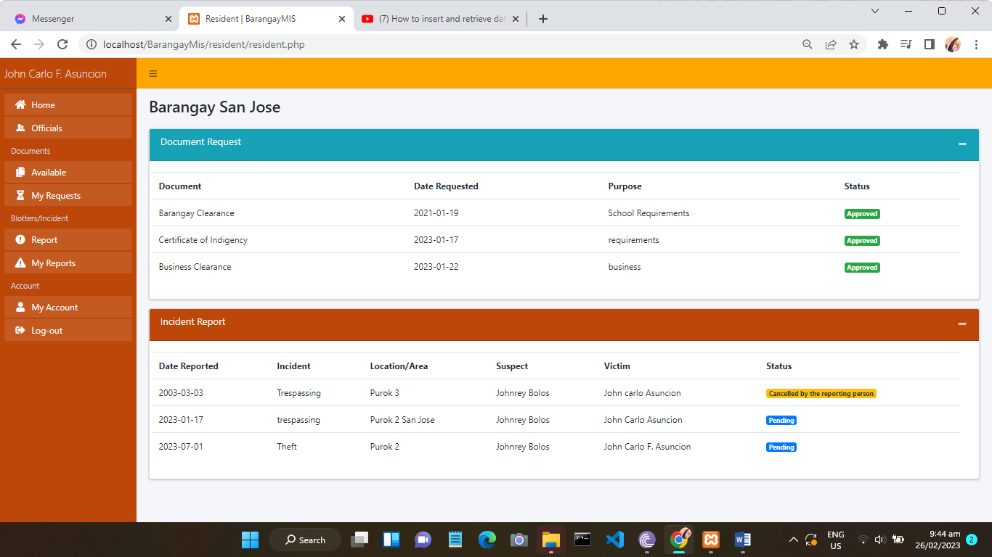

**RESIDENT’S PANEL**

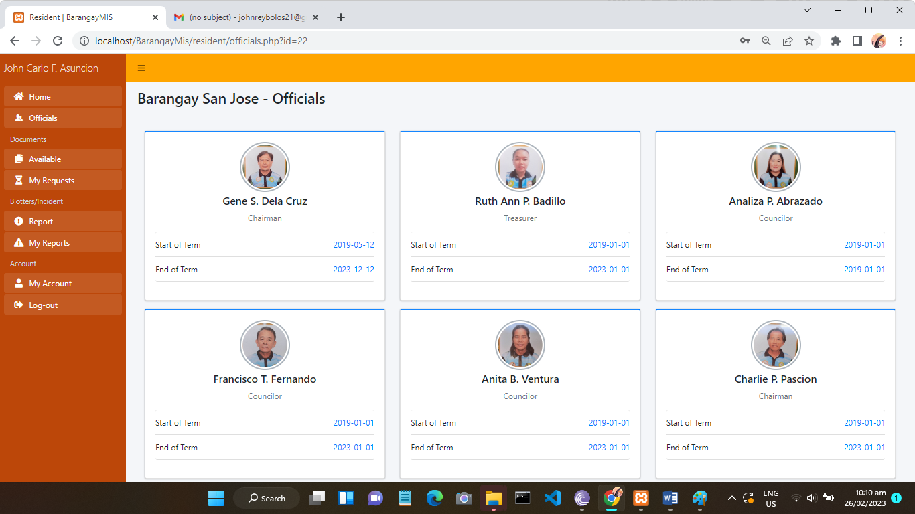 **LIST OF OFFICIALS IN RESIDENT’S INTERFACE**

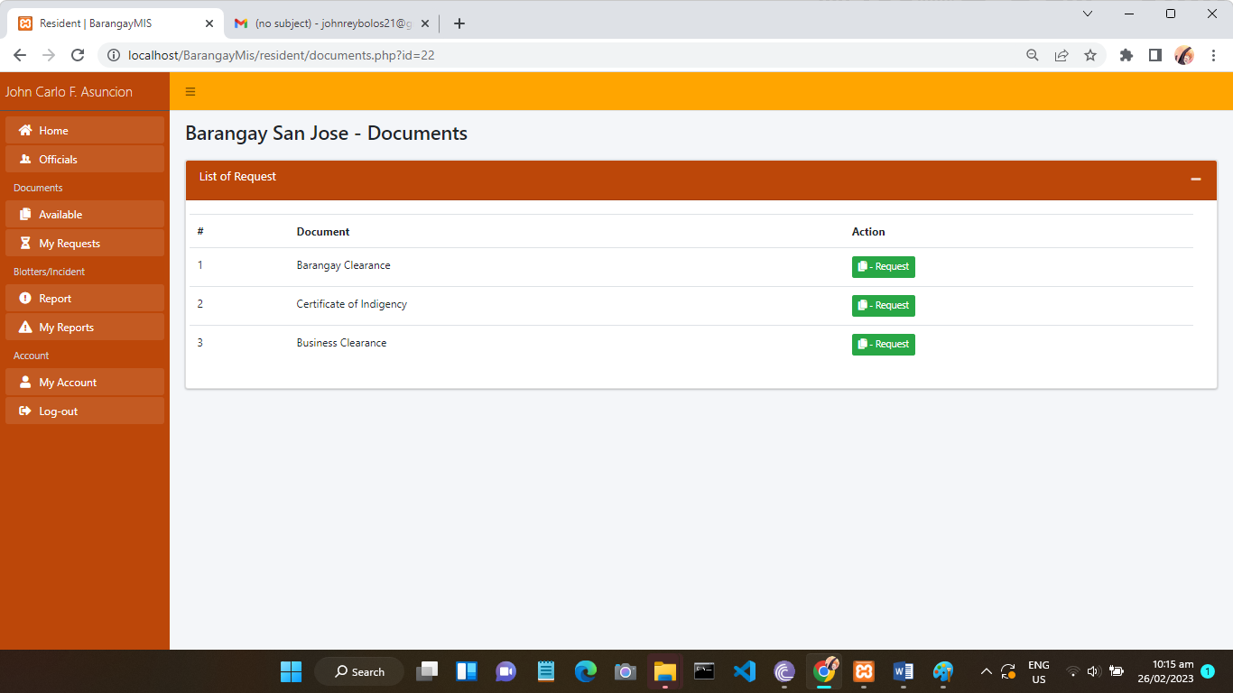 **LIST OF AVAILABLE REQUEST IN RESIDENT’S INTERFACE**

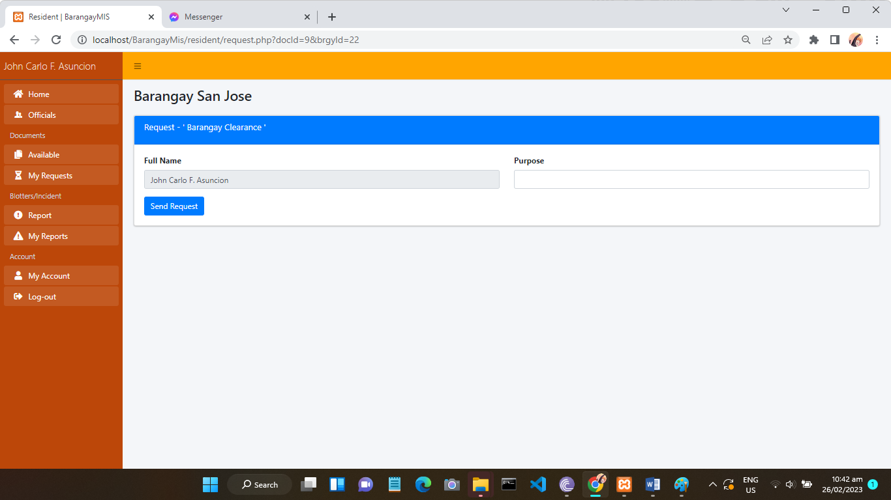**SEND REQUEST FORM**

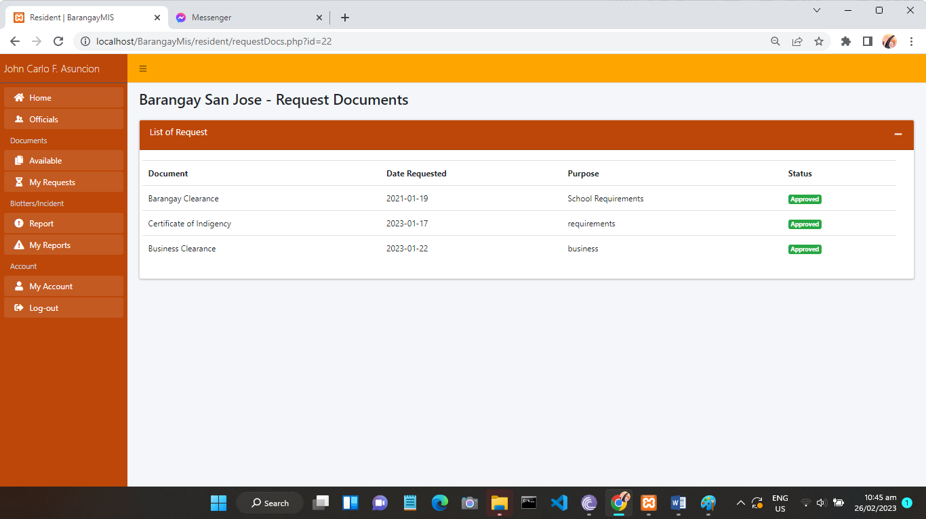 **LIST OF RESIDENT REQUEST**

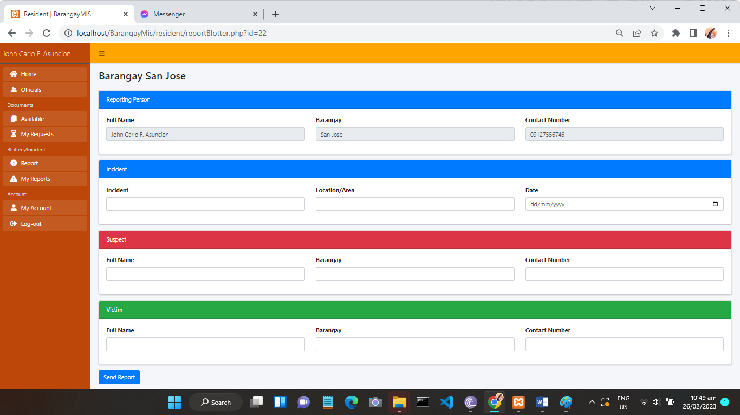**REPORT FORM**

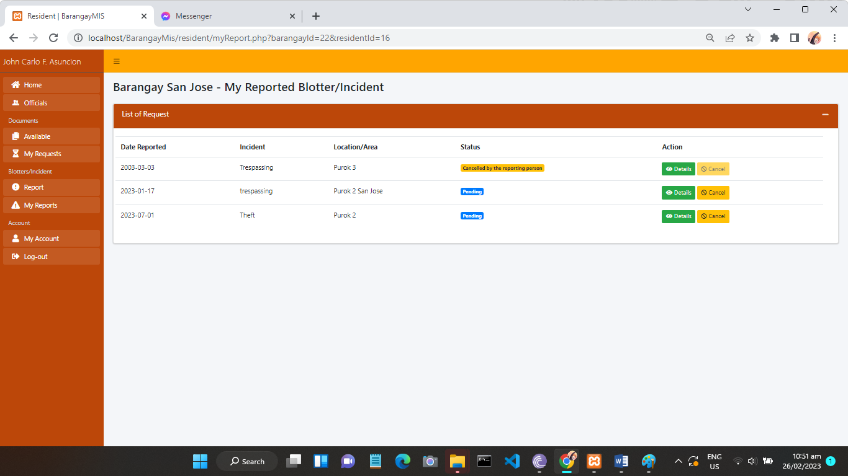**LIST OF REPORT**

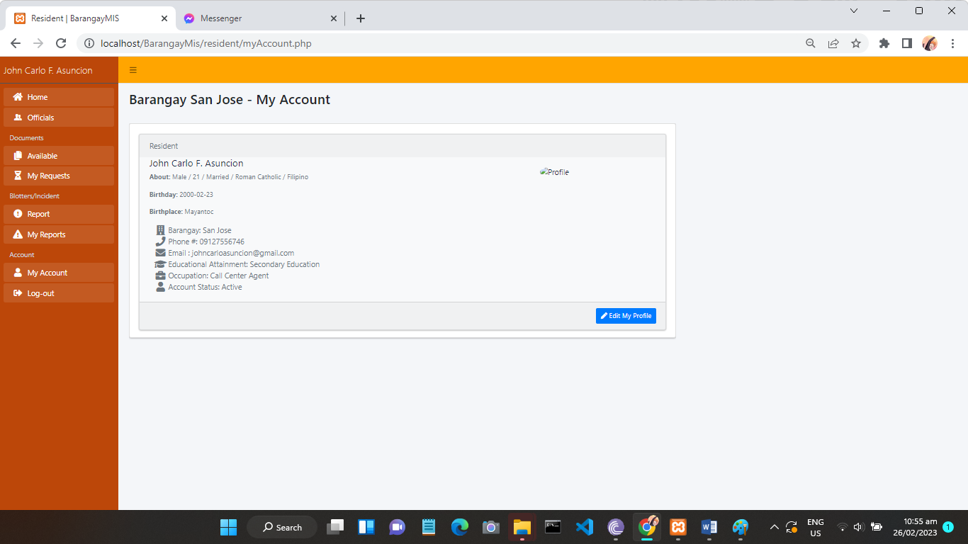**USER’S PROFILE**

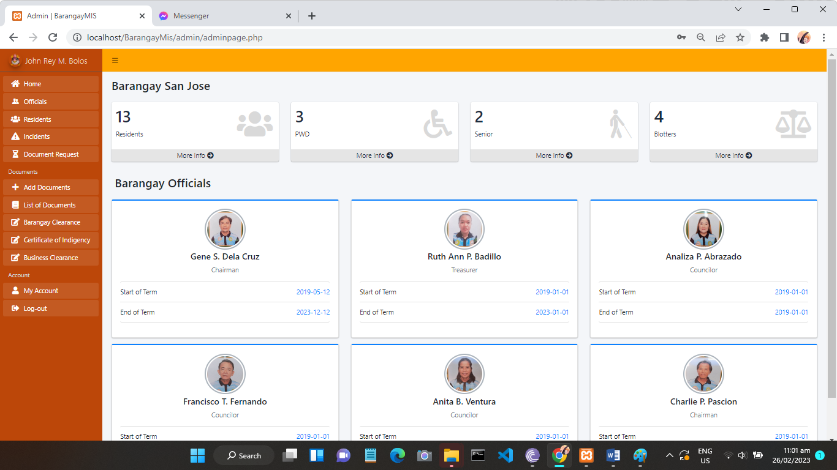**ADMIN PANEL AND STATISTICS**

**ADMIN PANEL AND STATISTICS**

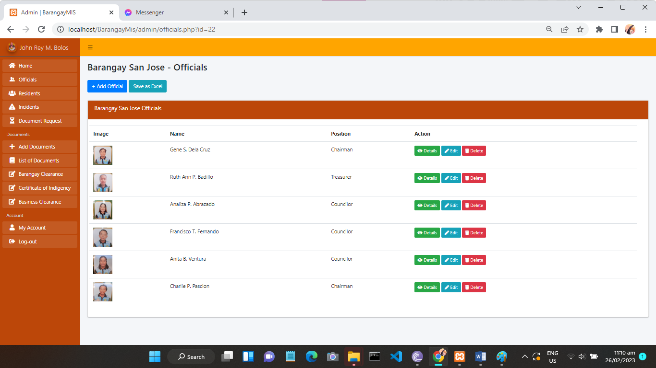 **OFFICIAL MENU**

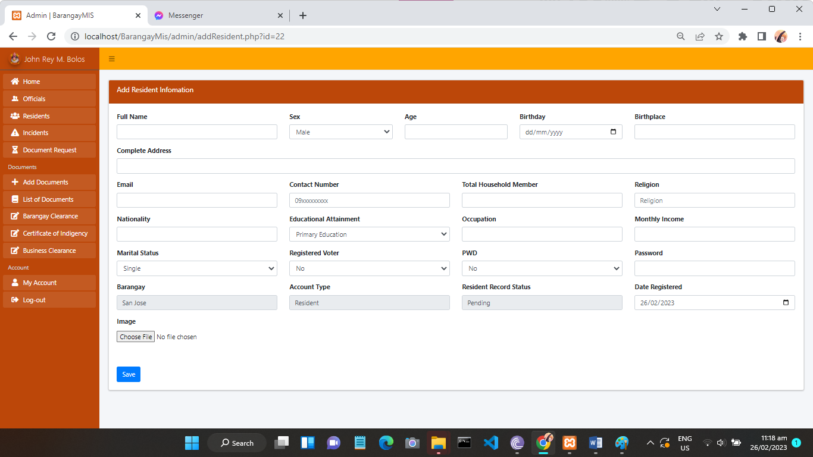**ADDING RESIDENT FORM**

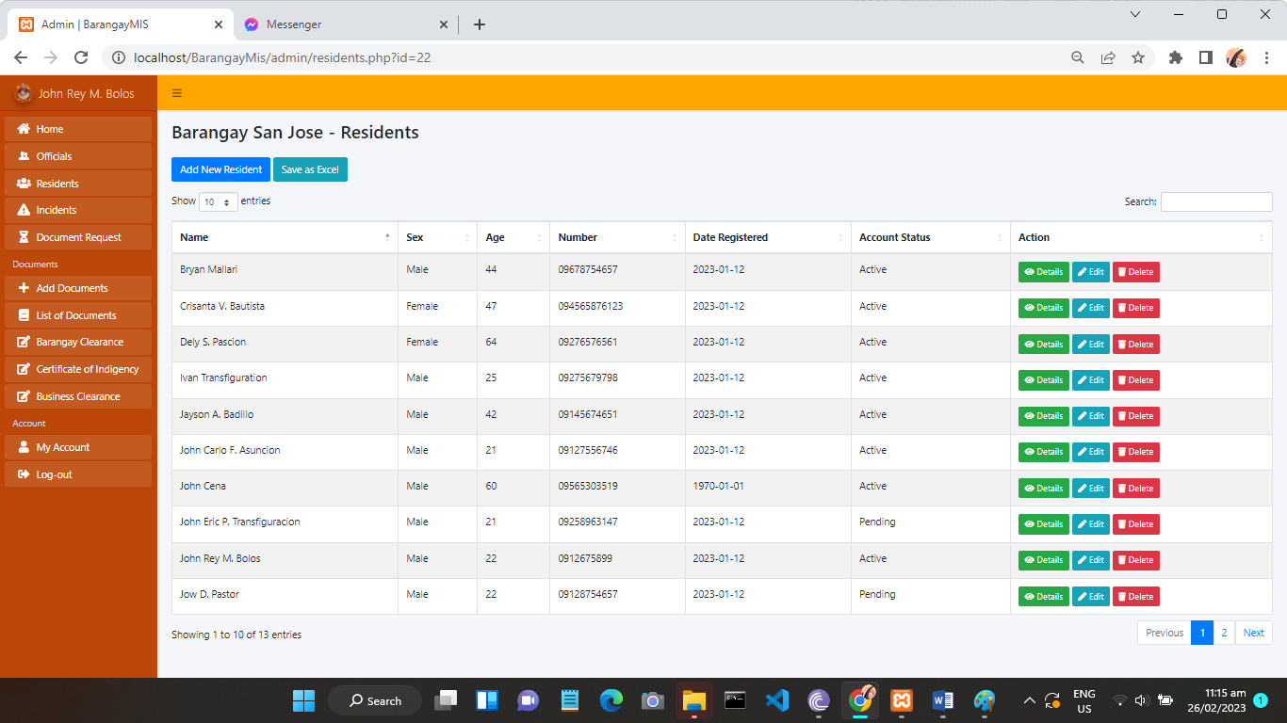**RESIDENT MENU**

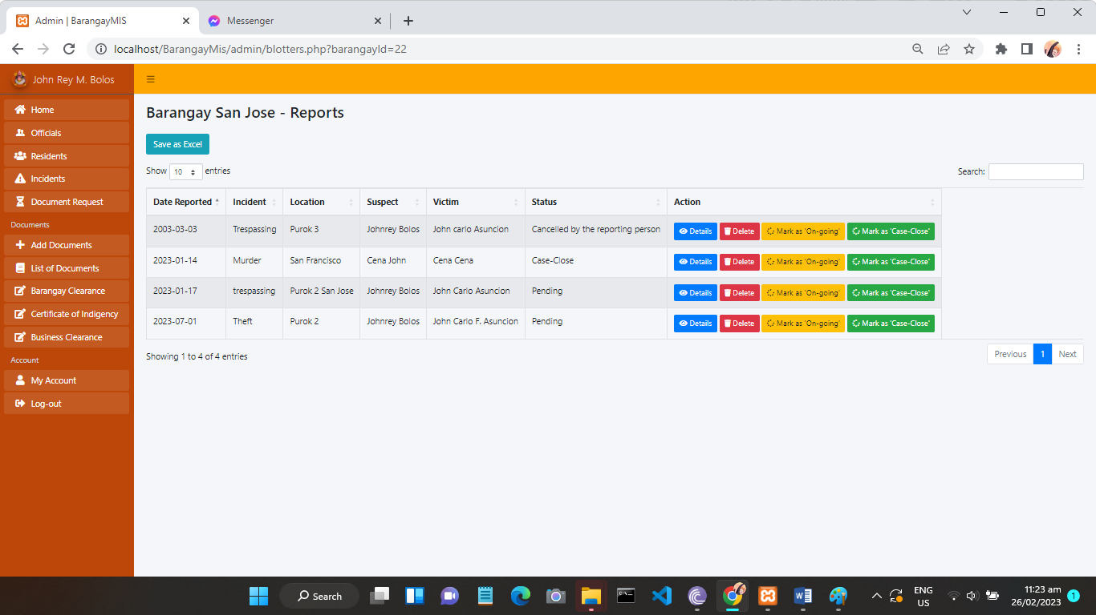**LIST OF PENDING REPORTS**

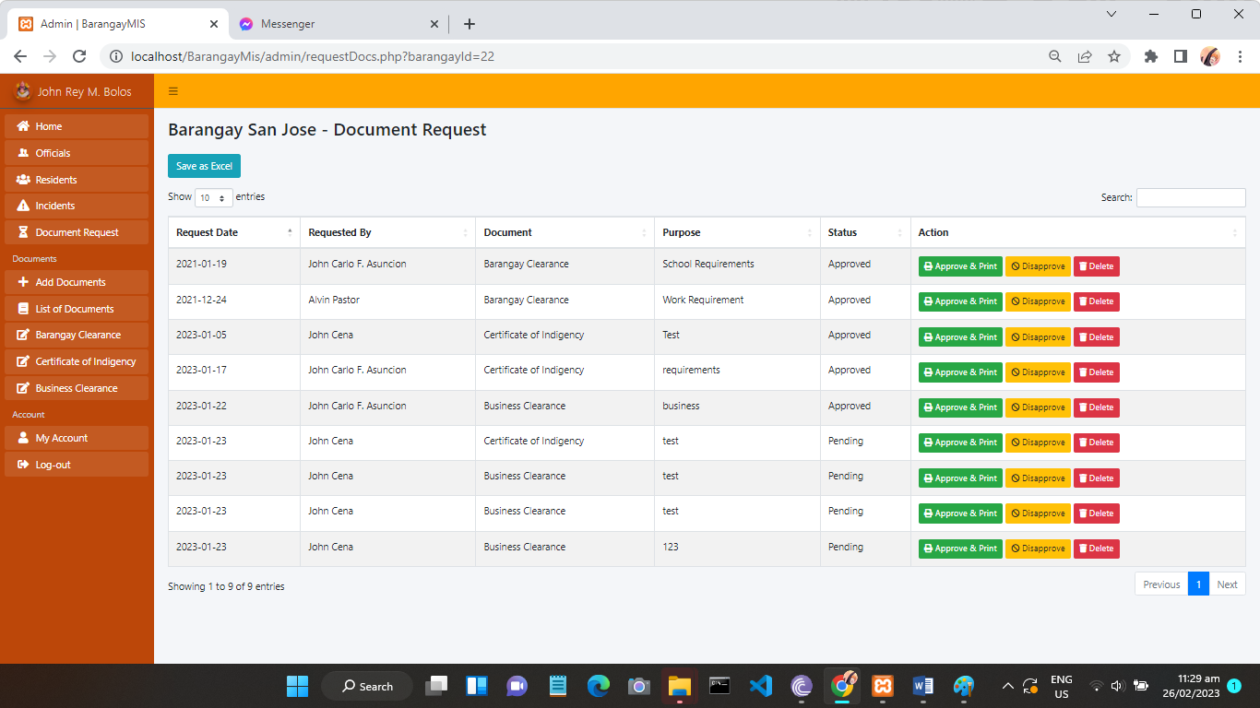**LIST OF PENDING DOCUMENT REQUEST**

**LIST OF PENDING DOCUMENT REQUEST**

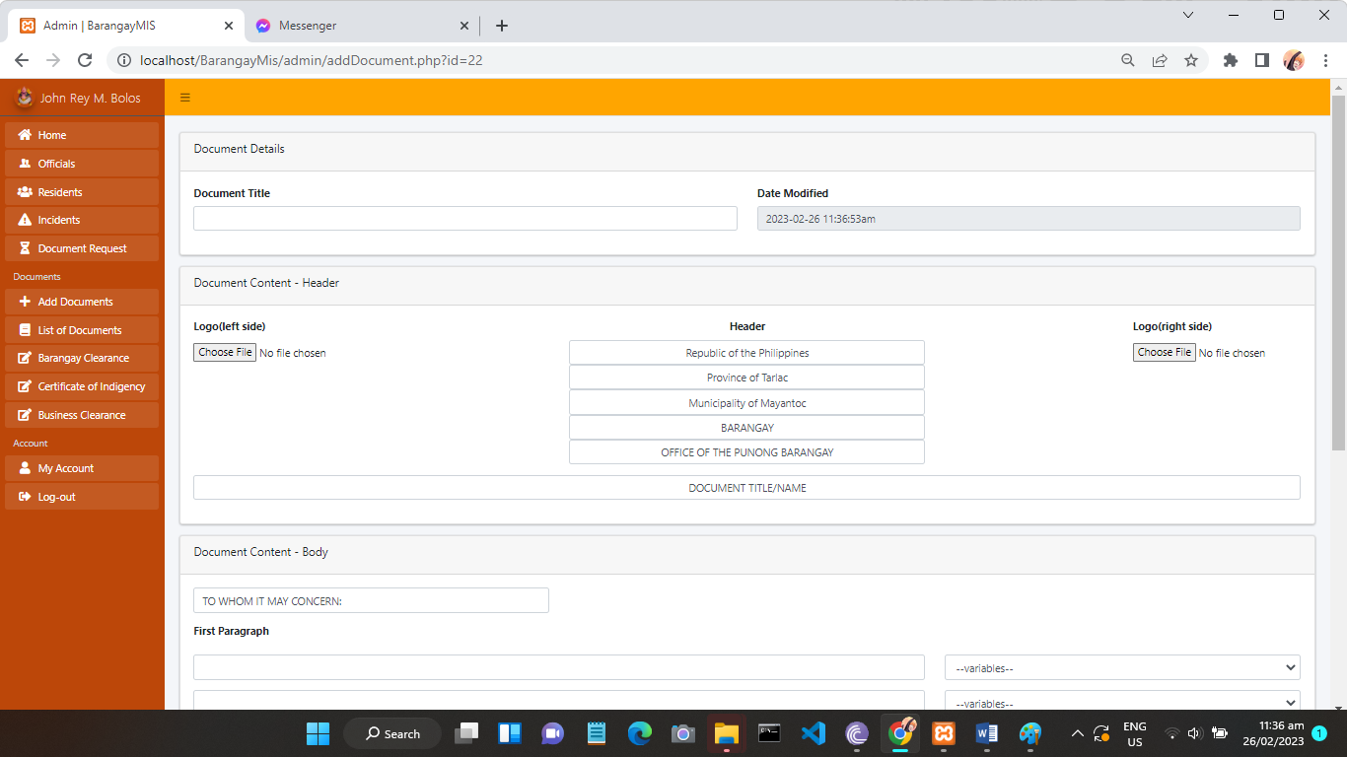**CREATING OR UPLOADING DOCUMENT FORM**

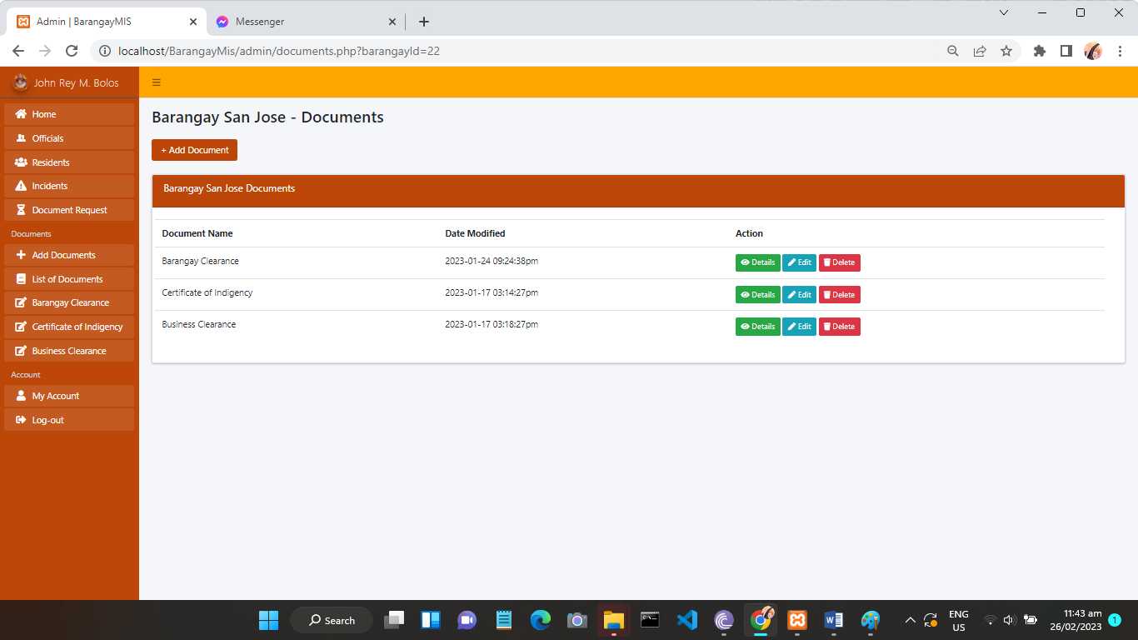**LIST OF CREATED DOCUMENTS**

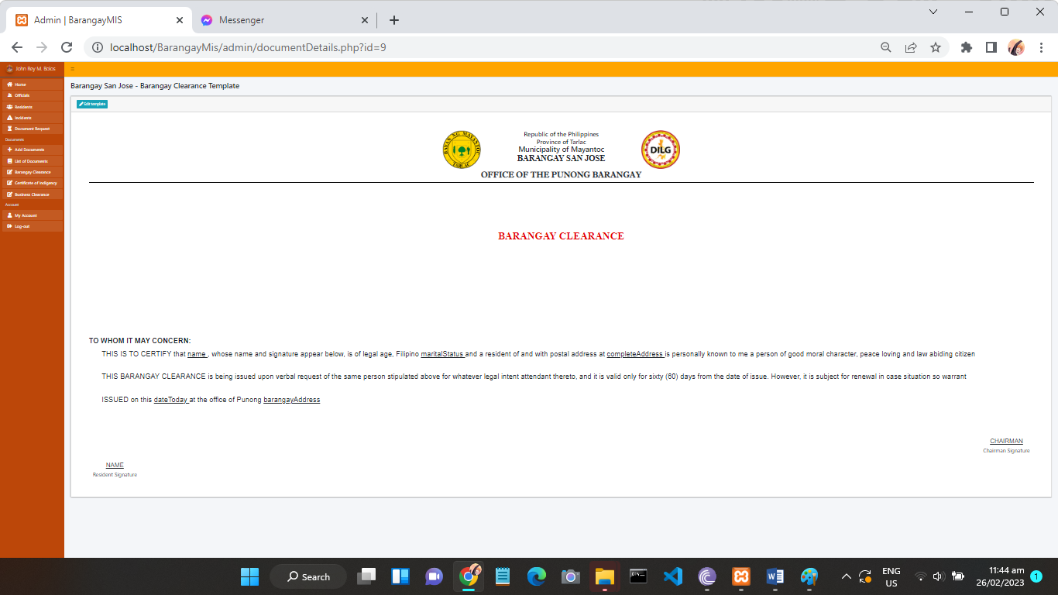**DOCUMENT EXAMPLE TEMPLATE**

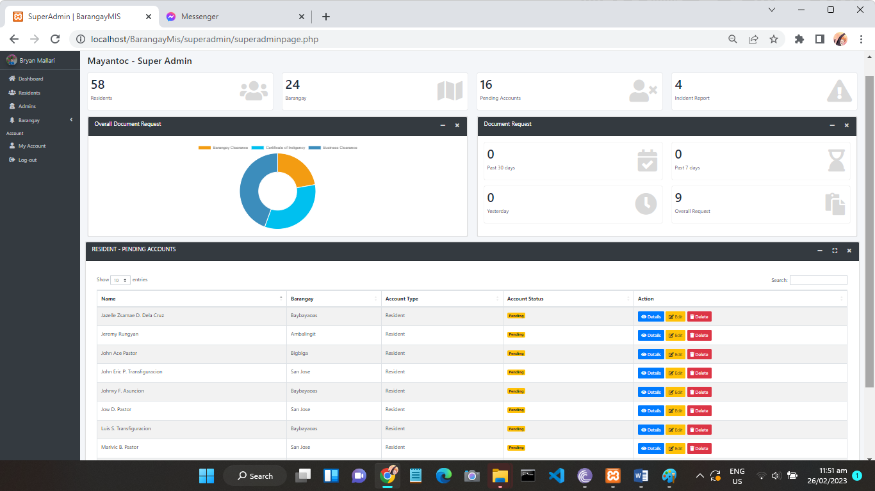**SUPERADMIN PANEL AND STATISTICS**

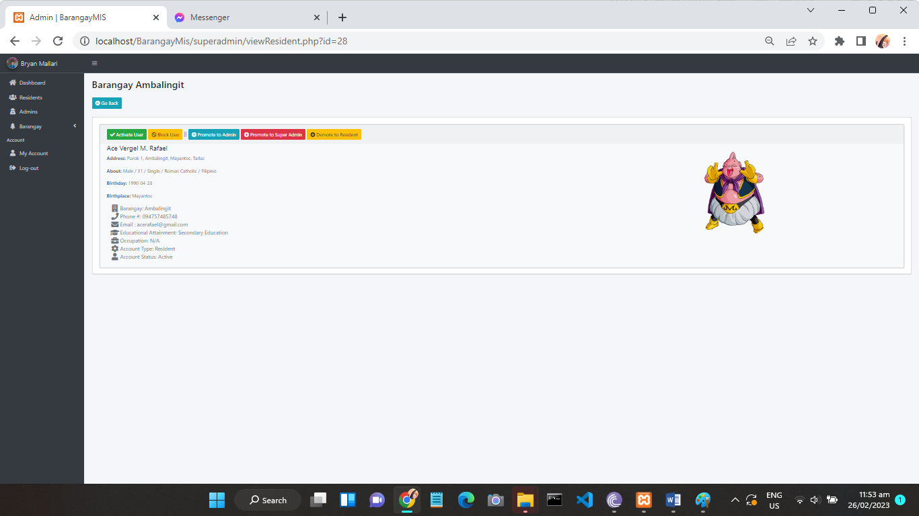**ASSIGNING POSITION OF RESIDENT**

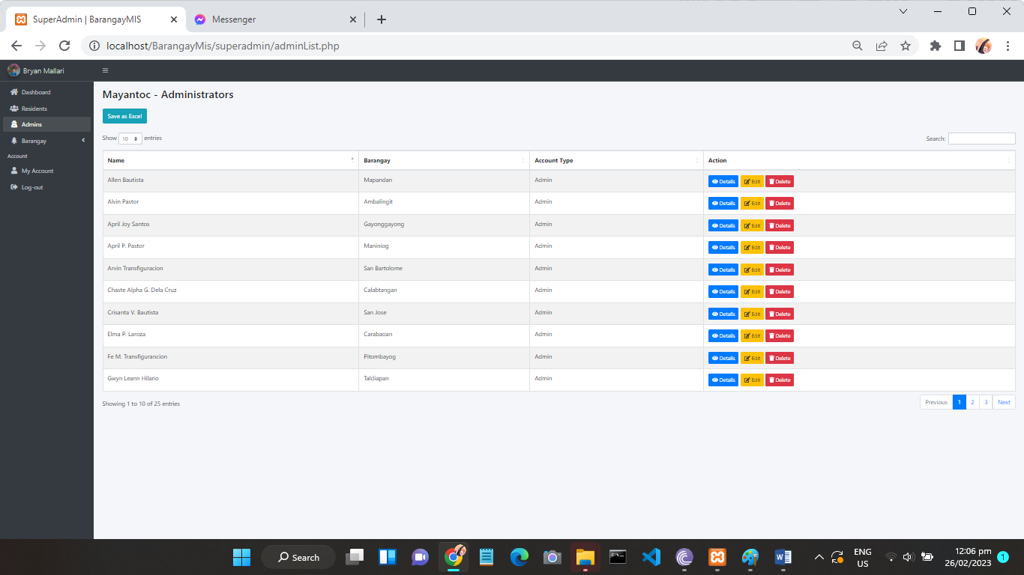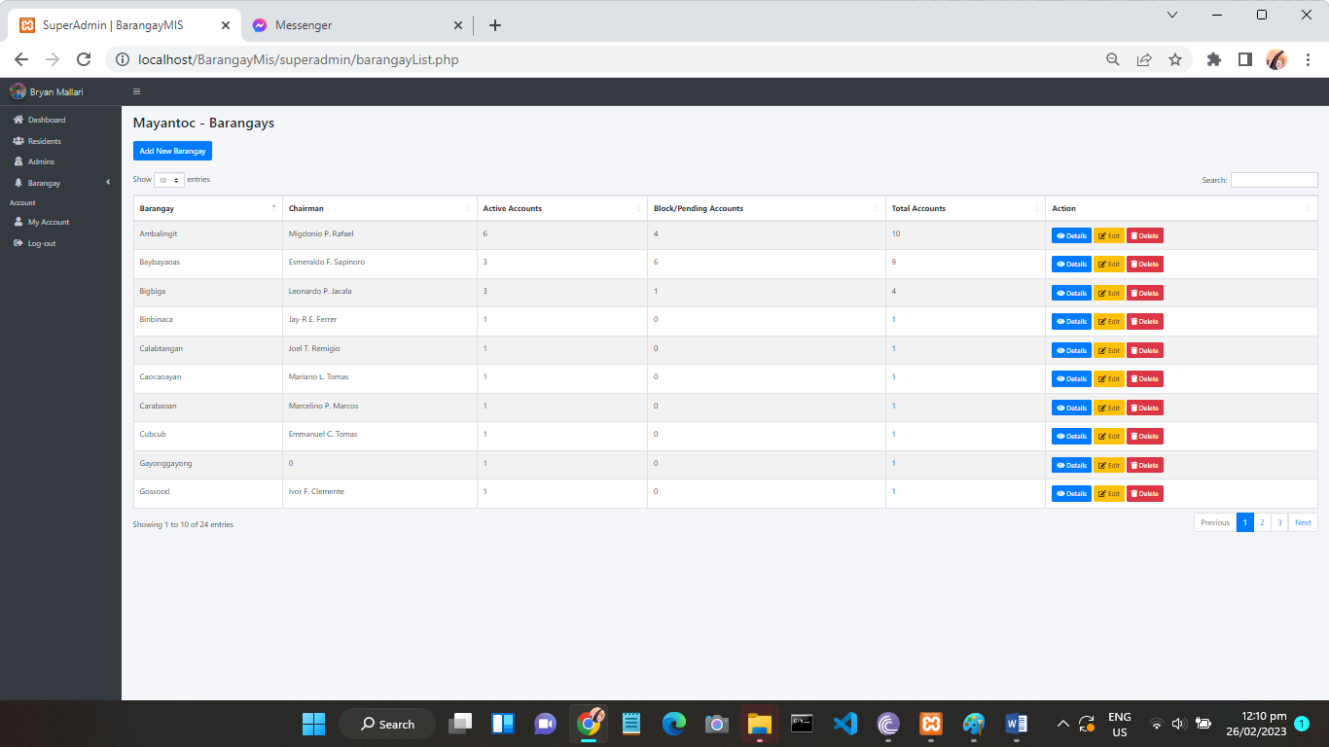**LIST OF ADMINISTRATORS**

**LIST OF BARANGAYS AND ADDING NEW BARANGAY**



##### Appendix B: Questionnaire

**BARANGAY MANAGEMENT INFORMATION SYSTEM FOR THE MUNICIPALITY OF MAYANTOC**

**Name:__________________________ Age:____________ Address:__________________________**

|  |  |  |  |  |  |
| --- | --- | --- | --- | --- | --- |
| **ADMIN QUESTIONNAIRE** | | | | | |
| **A.USABILITY** | **1** | **2** | **3** | **4** | **5** |
| 1. Organization of system data. |  |  |  |  |  |
| 2. Accomplishment of tasks. |  |  |  |  |  |
| 3. Flexibility of interface design |  |  |  |  |  |
| 4. The system is easy to learn |  |  |  |  |  |
| **B. FUNCTIONALITY** |  |  |  |  |  |
| 1. Adding, deleting, and updating records. |  |  |  |  |  |
| 2. Generating of reports and certifications |  |  |  |  |  |
| 3. Searching of documents/files |  |  |  |  |  |
| 4. Uploading of documents/files |  |  |  |  |  |

**BARANGAY MANAGEMENT INFORMATION SYSTEM FOR THE MUNICIPALITY OF MAYANTOC**

**Name:__________________________ Age:____________ Address:__________________________**

|  |  |  |  |  |  |
| --- | --- | --- | --- | --- | --- |
| **RESIDENT’S QUESTIONNAIRE** | | | | | |
| **A.USABILITY** | **1** | **2** | **3** | **4** | **5** |
| 1. Organization of data. |  |  |  |  |  |
| 2. Accomplishment of task. |  |  |  |  |  |
| 3. Flexibility of interface design. |  |  |  |  |  |
| 4. The system is easy to learn. |  |  |  |  |  |
| **B. FUNCTIONALITY** |  |  |  |  |  |
| 1. Submitting of files/documents. |  |  |  |  |  |
| 2. Generating of certifications, records, and other documents. |  |  |  |  |  |
| 3. Requesting of documents. |  |  |  |  |  |
| 4. Reporting of incidents and concerns. |  |  |  |  |  |

##### Appendix C: End Users’ Evaluator Profile

|  |  |  |
| --- | --- | --- |
| **ADMIN EVALUATORS** | | |
| **Name** | **Age** | **Address** |
| Renato Frondina Jr. | 25 | Barangay San Jose, Mayantoc, Tarlac |
| Analiza P. Abrazado | 49 | Barangay San Jose, Mayantoc, Tarlac |
| Gene S. Dela Cruz | 48 | Barangay San Jose, Mayantoc, Tarlac |
| Ruth Ann P. Badillo | 36 | Barangay San Jose, Mayantoc, Tarlac |
| Berting P. Transfiguration | 60 | Barangay San Jose, Mayantoc, Tarlac |
|  |  |  |
|  |  |  |
|  |  |  |
|  |  |  |

|  |  |  |
| --- | --- | --- |
| **RESIDENT EVALUATORS** | | |
| **Name** | **Age** | **Address** |
| John Lester Pungyan | 16 | Barangay San Jose, Mayantoc, Tarlac |
| Maricris T. Suatrez | 43 | Barangay San Jose, Mayantoc, Tarlac |
| Johnny Asuncion | 18 | Barangay San Jose, Mayantoc, Tarlac |
| April Joy Santos | 18 | Barangay San Jose, Mayantoc, Tarlac |
| Jazdie Zsamae D. Dela Cruz | 18 | Barangay San Jose, Mayantoc, Tarlac |
| Mark Aaron Abrazado | 18 | Barangay San Jose, Mayantoc, Tarlac |
| Elma P. Lanoza | 56 | Barangay San Jose, Mayantoc, Tarlac |
| Miguel S. Perlas | 54 | Barangay San Jose, Mayantoc, Tarlac |
| Niyon Laroza | 57 | Barangay San Jose, Mayantoc, Tarlac |
| Arvin Transfiguration | 26 | Barangay San Jose, Mayantoc, Tarlac |
| John Ace Pastor | 27 | Barangay San Jose, Mayantoc, Tarlac |
| Shiela Madela | 16 | Barangay San Jose, Mayantoc, Tarlac |
| Precious Anne Rafael | 14 | Barangay San Jose, Mayantoc, Tarlac |
| Jayson A. Badillo | 42 | Barangay San Jose, Mayantoc, Tarlac |
| Marivic B. Pastor | 42 | Barangay San Jose, Mayantoc, Tarlac |
| Crisanta V. Bautista | 47 | Barangay San Jose, Mayantoc, Tarlac |
| Dely S. Pascion | 64 | Barangay San Jose, Mayantoc, Tarlac |
| Ivan Transfiguration | 25 | Barangay San Jose, Mayantoc, Tarlac |
| Alvin Pastor | 31 | Barangay San Jose, Mayantoc, Tarlac |
| Rolly Agustin | 24 | Barangay San Jose, Mayantoc, Tarlac |
| John Eric P. Transfiguration | 21 | Barangay San Jose, Mayantoc, Tarlac |
| Winda P. Lagunero | 20 | Barangay San Jose, Mayantoc, Tarlac |
| Jow D. Pastor | 22 | Barangay San Jose, Mayantoc, Tarlac |
| Emerson Mariano | 30 | Barangay San Jose, Mayantoc, Tarlac |
| Ace Vergel M. Rafael | 33 | Barangay San Jose, Mayantoc, Tarlac |
| Jeremy Pungyan | 23 | Barangay San Jose, Mayantoc, Tarlac |
| Aris Joy Guillermo | 27 | Barangay San Jose, Mayantoc, Tarlac |
| Rowena M. Siatrez | 41 | Barangay San Jose, Mayantoc, Tarlac |
| Gilbert B. Siatrez | 38 | Barangay San Jose, Mayantoc, Tarlac |
| Ma. Theresa Pastor | 34 | Barangay San Jose, Mayantoc, Tarlac |
| Junnel Gomez | 45 | Barangay San Jose, Mayantoc, Tarlac |
| Rowell Transfiguration | 37 | Barangay San Jose, Mayantoc, Tarlac |
| Teresita Siatrez | 71 | Barangay San Jose, Mayantoc, Tarlac |
| Ailen Anitado | 36 | Barangay San Jose, Mayantoc, Tarlac |
| Mary Ann V. Agustin | 35 | Barangay San Jose, Mayantoc, Tarlac |
| Wilma Pascion | 59 | Barangay San Jose, Mayantoc, Tarlac |
| Joel S. Agustin | 42 | Barangay San Jose, Mayantoc, Tarlac |
| Peter S. Pascion | 28 | Barangay San Jose, Mayantoc, Tarlac |
| Transfiguratuin Luis S. | 26 | Barangay San Jose, Mayantoc, Tarlac |
| Mariane Siatrez | 18 | Barangay San Jose, Mayantoc, Tarlac |
| Genalyn I. Agustin | 43 | Barangay San Jose, Mayantoc, Tarlac |
| Jonathan Bautista | 28 | Barangay San Jose, Mayantoc, Tarlac |
| Arlista Asuncion | 68 | Barangay San Jose, Mayantoc, Tarlac |
| Nelson Agustin | 44 | Barangay San Jose, Mayantoc, Tarlac |
| Gwynn Leann Hilario | 15 | Barangay San Jose, Mayantoc, Tarlac |
| Zenaida B. Pastor | 67 | Barangay San Jose, Mayantoc, Tarlac |
| Sylvia G. Transfiguration | 54 | Barangay San Jose, Mayantoc, Tarlac |
| Fe M. Transfiguration | 48 | Barangay San Jose, Mayantoc, Tarlac |
| Lorita Mercado | 53 | Barangay San Jose, Mayantoc, Tarlac |
| Neil John Caing | 19 | Barangay San Jose, Mayantoc, Tarlac |
| John Lee Transfiguration | 20 | Barangay San Jose, Mayantoc, Tarlac |
| April P. Pastor | 26 | Barangay San Jose, Mayantoc, Tarlac |
| Allen Bautista | 18 | Barangay San Jose, Mayantoc, Tarlac |
| Jayson Agustin | 18 | Barangay San Jose, Mayantoc, Tarlac |

##### Appendix D: Source Code

<?php session_start(); ?>

<!DOCTYPE html>

<html lang="en">

<head>

  <title>Barangay MIS Login</title>

  <meta charset="UTF-8">

  <meta name="viewport" content="width=device-width, initial-scale=1">

  <link rel="icon" type="image/png" href="images/icons/favicon.ico"/>

  <link rel="stylesheet" type="text/css" href="vendor/bootstrap/css/bootstrap.min.css">

  <link rel="stylesheet" type="text/css" href="fonts/font-awesome-4.7.0/css/font-awesome.min.css">

  <link rel="stylesheet" type="text/css" href="fonts/Linearicons-Free-v1.0.0/icon-font.min.css">

  <link rel="stylesheet" type="text/css" href="vendor/animate/animate.css">

  <link rel="stylesheet" type="text/css" href="vendor/css-hamburgers/hamburgers.min.css">

  <link rel="stylesheet" type="text/css" href="vendor/animsition/css/animsition.min.css">

  <link rel="stylesheet" type="text/css" href="vendor/select2/select2.min.css">

  <link rel="stylesheet" type="text/css" href="vendor/daterangepicker/daterangepicker.css">

  <link rel="stylesheet" type="text/css" href="css/util.css">

  <link rel="stylesheet" type="text/css" href="css/main.css">

</head>

<body>

  <div class="limiter">

    <div class="container-login100">

      <div class="wrap-login100">

        <div class="login100-form-title" style="background-image: url(images/bg-01s.jpg);">

          <span class="login100-form-title-1">Barangay Login</h3></span>

        </div>

        <form class="login100-form validate-form" action="#" method="post">

          <div class="wrap-input100 validate-input m-b-26" data-validate="Username is required">

            <span class="label-input100">Email</span>

            <input class="input100" type="email" name="userEmail" placeholder="Enter Email">

            <span class="focus-input100"></span>

          </div>

          <div class="wrap-input100 validate-input m-b-18" data-validate = "Password is required">

            <span class="label-input100">Password</span>

            <input class="input100" type="password" name="userPassword" placeholder="Enter Password">

            <span class="focus-input100"></span>

          </div>

          <div class="container-login100-form-btn">

            <input type="submit" name="signIn" value="Log-in" class="login100-form-btn">

          </div>

        </form>

        <?php

          include 'connection.php';

          $con = connect();

          $_SESSION['residentId']= 0;

          if (isset($_POST['signIn'])) {

            if ($_POST['userEmail'] != "" AND $_POST['userPassword'] != "") {

              $logInSQL = "SELECT * FROM resident WHERE email = '".$_POST['userEmail']."' AND password = '".$_POST['userPassword']."';";

              $accountRecord = $con->query($logInSQL);

                foreach ($accountRecord as $ar) {}

              if ($accountRecord->num_rows <= 0) {

                echo '<script>alert("This Password is Incorrect.")</script>';

                echo '<script>window.location="login.php"</script>';

              }else{

                if($ar['residentRecordStatus'] == 'Blocked'){

                  echo '<script>alert("Account is Blocked")</script>';

                  echo '<script>window.location="login.php"</script>';

                }

                if ($ar['residentRecordStatus'] == 'Pending'){

                  echo '<script>alert("Account is being reviewed by Admin.")</script>';

                  echo '<script>window.location="login.php"</script>';

                }

                $_SESSION['residentId'] = $ar['residentId'];

                if($ar['accountType'] == 'Admin'){

                  echo '<script>window.location="admin/adminpage.php"</script>';

                }elseif ($ar['accountType'] == 'SuperAdmin'){

                  echo '<script>window.location="superadmin/superadminpage.php"</script>';

                }elseif ($ar['accountType'] == 'Resident'){

                  echo '<script>window.location="resident/resident.php"</script>';

                }else{

                  echo '<script>window.location="index.php"</script>';

                }

              }

            }else{

              echo 'Please provide email and password';

            }

          }else{

          }

        ?>

      </div>

    </div>

  </div>

  <script src="vendor/jquery/jquery-3.2.1.min.js"></script>

  <script src="vendor/animsition/js/animsition.min.js"></script>

  <script src="vendor/bootstrap/js/popper.js"></script>

  <script src="vendor/bootstrap/js/bootstrap.min.js"></script>

  <script src="vendor/select2/select2.min.js"></script>

  <script src="vendor/daterangepicker/moment.min.js"></script>

  <script src="vendor/daterangepicker/daterangepicker.js"></script>

  <script src="vendor/countdowntime/countdowntime.js"></script>

  <script src="js/main.js"></script>

</body>

</html>

!DOCTYPE html>

<html lang="en">

<head>

  <meta charset="utf-8">

  <meta name="viewport" content="width=device-width, initial-scale=1">

  <title>Resident | BarangayMIS</title>

  <?php include 'components/stylesheets.php';?>

</head>

<body class="hold-transition sidebar-mini layout-fixed">

  <div class="wrapper">

    <?php include 'components/navBar.php';?>

    <?php include 'components/sidebar.php';?>

    <?php

      error_reporting(0);

      $myInfoSql = "

        SELECT * FROM resident r

        LEFT JOIN barangay b ON r.barangayId = b.barangayId

        WHERE residentId = '".$_SESSION['residentId']."'";

      $myProfile = $con->query($myInfoSql);

      foreach ($myProfile as $mp) {}

      if (empty($mp)) {echo '<script>window.location="../index.php"</script>';}

    ?>

    <div class="content-wrapper">

      <div class="content-header">

        <div class="container-fluid">

          <div class="row mb-2">

            <div class="col-sm-6">

              <h1 class="m-0"><?php echo 'Barangay '. $mp['barangayName'];?> - Documents</h1>

            </div>

          </div>

        </div>

      </div>

      <section class="content">

        <div class="container-fluid">

          <div class="row">

            <div class="col-md-12">

              <div class="card card-info">

                <div class="card-header" style="background-color: #bc4709;">

                  <h3 class="card-title">List of Request</h3>

                  <div class="card-tools">

                    <button type="button" class="btn btn-tool" data-card-widget="collapse"><i class="fas fa-minus"></i></button>

                  </div>

                </div>

                <div class="card-body">

                  <div class="row table-responsive">

                <table class="table">

                  <thead>

                    <tr>

                      <th>#</th>

                      <th>Document</th>

                      <th>Action</th>

                    </tr>

                  </thead>

                  <tbody>

                    <?php

                      $officials = "SELECT * FROM documents WHERE barangayId = '".$_GET['id']."'";

                      $officialsDetails = $con->query($officials);

                      $counter = 0;

                      foreach ($officialsDetails as $od) {

                        $counter++;

                        ?>

                        <tr>

                          <td><?php echo $counter?> </td>

                          <td><?php echo $od['documentTitle'] ?></td>

                          <td>

                            <a href="<?php echo 'request.php?docId='.$od['documentId'].'&brgyId='.$mp['barangayId']; ?>" class="btn btn-success btn-sm"><i class="fa fa-copy"></i> - Request</a>

                          </td>

                        </tr>

                        <?php

                      }

                    ?>

                  </tbody>

                </table>

              </div>

                </div>

              </div>

            </div>

          </div>

        </div>

<?php

    function connect($flag=TRUE){

        $servername = "localhost";

        $username = "root";

        $password = "";

        $dbName = "barangay_system";

        if($flag){$conn = new mysqli($servername, $username, $password, $dbName);}

        else{$conn = new mysqli($servername, $username, $password);}

        if ($conn->connect_error) {die("Connection failed: $conn->connect_error");}

        return $conn;

    }

?>

##### Appendix E: Gramarian Certificate

##### Appendix F: TAU-CET-QF-02 ADVISORY COMMITTEE

##### Appendix G: TAU-CET-QF-03 CAPSTONE TITLE APPROVAL

##### Appendix H: TAU-CET-QF-07 ORAL EXAMINATION

##### Appendix I: TAU-CET-QF-08 ORAL EXAMINATION

##### Appendix J: TAU-CET-QF-10 FINAL CIRCULATION

**Appendix K: TAU-CET-QF-11 FINAL COPY OF MANUSCRIPT**